

October 30, 2020 CARES ACT Report – Final Report
Report Date: October 30, 2020

- Acknowledgement: Oakland University acknowledges that it signed and returned to the Department of Education the Certification and Agreement on April 15, 2020 and assures it intends to use no less than 50 percent of the funds received under Section 18004(a)(1) of the CARES Act to provide Emergency Grants to students.

- Total amount of funds the Oakland University will or has received from the Department for Emergency Grants to Students: $6,898,412

- Total amount of Emergency Grants distributed to students as of October 30, 2020: $6,898,412

- Estimated number of students at Oakland University eligible to receive Emergency Grants as of report date: 14,500

- Total number of students who have received an Emergency Grant as of report date: 11,504

- The method(s) used by Oakland University to determine which students receive Emergency Grant and how much under Section 18004(a)(1) of the CARES Act:

With guidance from the U.S. Department of Education, a committee collaborated with OU leadership to establish the following criteria:
Phase I Awards:
The first wave of awards was disbursed to eligible students who were enrolled in the Winter 2020 semester. These grants were automatic; no application process was necessary.
Eligibility:
- Must be Title IV Federal Aid eligible
  - Competed the 2019-20 FAFSA
  - Awarded some type of federal aid/loan
  - Verification complete, if federally selected
- Must be enrolled in Winter 2020 semester in at least 1 credit hour as of March 13
- Must not be enrolled in exclusively online courses as of March 13 for the Winter 2020 semester

Grants:
- Automatic grant (no application process)
- Distributed in the same manner as financial aid refunds
- Does not need to be repaid

Phase II Awards:
The second phase of awards are being distributed via and application process where students can apply for an additional $500 of emergency grants.

Eligibility:
- Must be Title IV Federal Aid eligible
  - Competed the 2019-20 FAFSA
  - Awarded some type of federal aid/loan
  - Verification complete, if federally selected
- Must be enrolled in Winter 2020 or Summer 2020 semesters in at least 1 credit hour
- Must not be enrolled in exclusively online courses as of March 13 for the Winter 2020 semester

Grants:
- Application process online
- Distributed in the same manner as financial aid refunds
- Does not need to be repaid

Phase III Awards:
The third phase of awards are being distributed via and application process where students can apply for an additional $500 of emergency grants.

Eligibility:
- Must be Title IV Federal Aid eligible
  - Competed the 2020-21 FAFSA
  - Awarded some type of federal aid/loan
  - Verification complete, if federally selected
- Must be enrolled in Fall 2020 semesters in at least 1 credit hour
- Must not be enrolled in one of Oakland University’s 100% online programs

Grants:
- Amount $500
- Application process online – deadline October 15, 2020
- Distributed in the same manner as financial aid refunds
- Does not need to be repaid
- Application notice emailed to new students enrolled in Fall 2020

- Any instructions, directions, or guidance provided by the institution to students concerning the Emergency Grants.

See attached email communications to students and visit the CARES Act: Emergency Funding webpage listed below.
https://www.oakland.edu/financialservices/cares-act-emergency-funding/

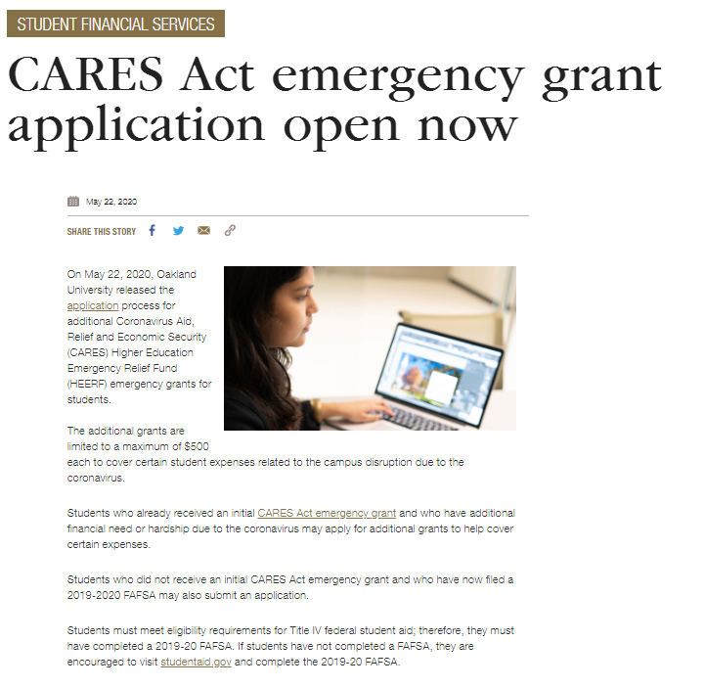
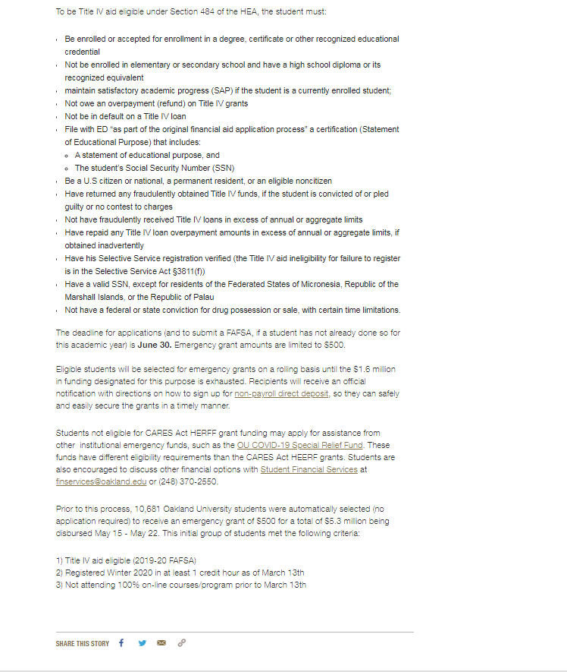

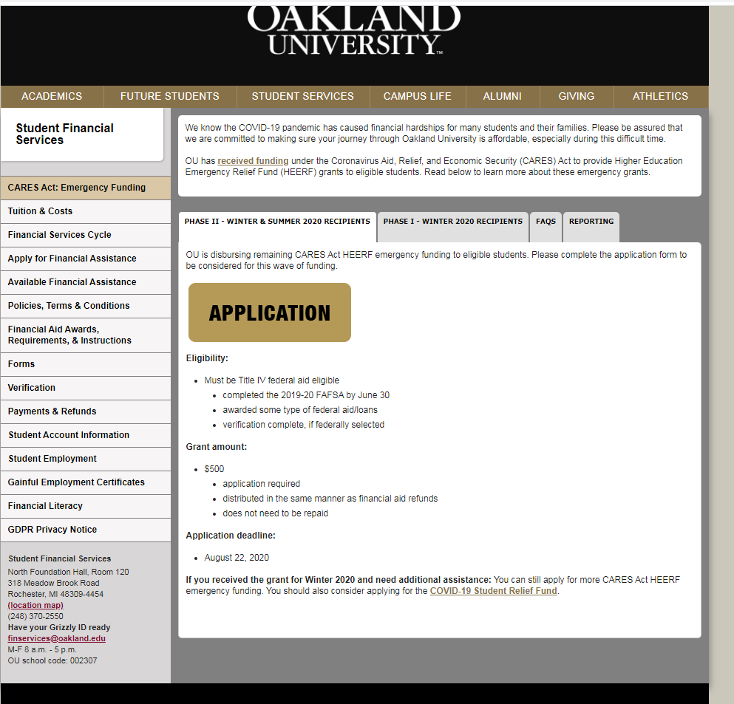

https://oakland.edu/oumagazine/news/Financial-services/2020/students-may-still-apply-for-cares-act-emergency-grant-funds


Enrollment Management



Dear Dawn:

At Oakland University, we are committed to making sure your journey through college is affordable. Fortunately, the university has received funding under the Coronavirus Aid, Relief, and Economic Security (CARES) Act to provide Higher Education Emergency Relief Fund (HEERF) emergency grants to eligible students.

We are pleased to inform you that you may be eligible for this grant because you meet the following criteria:
- Title IV federal aid eligible
  - completed the 2020-21 FAFSA
  - awarded some type of federal aid/loans
  - verification complete, if federally selected
- Enrolled in the Fall 2020 semester in at least one (1) credit hour
- Not enrolled in one of Oakland University's 100% online programs
Please note that funding is limited. Your next step is to apply for the grant by October 15, 2020.

Grants of $500 will be awarded. The grant funds will not be applied to tuition, fees or any outstanding balances and will be refunded directly to you. These grants do not need to be repaid.

If you are awarded the funds, the fastest and safest way to receive the funds is to enroll in OU non-payroll direct deposit. If you are currently enrolled in direct deposit, please confirm that your banking information is accurate on MySAIL.
We hope this grant will help to alleviate some of the hardships you have experienced due to the Coronavirus. Please be assured that we are committed to making sure you are successful at OU, and have several additional resources and opportunities in place to help, including a Student Emergency Relief Fund.

If you need any assistance with managing your future semester finances, please contact Student Financial Services at (248) 370-2550 to discuss your options.
Best wishes for a healthy and successful future.

Dawn Aubry
Vice President for Enrollment Management



STUDENT FINANCIAL SERVICES

OU distributes CARES Act grants to more than 11,500 students
October 21, 2020 FacebookTwitterEmailCopy Link
All emergency grant funding that Oakland University received from the Coronavirus Aid, Relief and Economic Security (CARES) Higher Education Emergency Relief Fund (HEERF) has been disbursed to eligible students. A total of $6,898,412 in emergency grants was distributed among 11,504 students to help ease financial burdens brought about by the pandemic.
The Coronavirus Aid, Relief and Economic Security (CARES) Act was passed by Congress in March and provided a total of $13,796,824 to Oakland University in higher education emergency relief funding. By law, half of the funds were to be distributed directly to students in the form of emergency grants to cover certain expenses related to unexpected financial needs due to the coronavirus pandemic. The grants were up to a maximum of $500 and do not need to be repaid.
In May, 10,850 Oakland University students were automatically selected (no application required) to receive an emergency grant of up to $500 for a total of $5.4 million. This initial group of students met the following criteria:
- Title IV aid eligible (2019-20 FAFSA)
- Registered for Winter 2020 in at least 1 credit hour as of March 13
- Not attending 100 percent online courses/program prior to March 13
In June, a second wave of funding was made available by application for students enrolled in summer and/or fall classes, which yielded an additional 2,194 awards for a total of $1,091,263 disbursed to students. The application process allowed some students registered for summer classes to receive a second award of up to $500.
In September, a third wave of funding was made available by application for students enrolled in summer and/or fall classes, which yielded an additional 765 awards for a total of $382,149 disbursed to students.
Students who need assistance with managing future semester finances should contact Student Financial Services at (248) 370-2550 to discuss options.

