Continuing Education Announcement
SAVE THE DATE: SATURDAY, SEPTEMBER 15, 2018 7:45 AM – 2:15 PM
Clinical examination and treatment of the injured runner:
Hypothesis driven by experience, research and technology

Course Description: We will introduce the very latest evidence about common lower extremity overuse injuries and link them to clinically available running gait analysis technology. We will enable practitioners to develop case specific hypothesis driven clinical exams including fitness testing to hone in on efficacious intervention including manual therapy, therapeutic exercise, fitness training and running gait drill training.

Speakers:
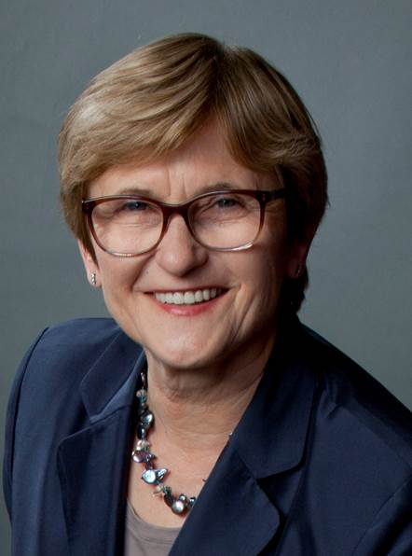
Kornelia Kulig, PhD, PT, FAPTA, FAAOMPT (Hon) is a Professor and Co-Director of the Jacquelin Perry Musculoskeletal Biomechanics Research Laboratory at the University of Southern California. Her research is clinically motivated, theoretically informed and experimentally tested. She studies human movement and postural control in a model of clinical conditions characterized by frequent recurrence of painful symptoms. She is a Founding Member of the American Academy of Orthopedic Manual Physical Therapists.

Liz Poppert DPT, MS, OCS blends academics at the University of Southern California and clinical work at her Santa Monica private practice. She educates practitioners to apply best evidence to maximize patient outcomes with rehabilitative exercise programs especially for individuals with low back pain and running related injuries. Dr. Poppert is a member of the APTA Running Special Interest Group, is certified as an ACSM Fitness Specialist and United States Track and Field Level One Coach. She is avid recreational runner and enjoys training and competing with the Track Club of Los Angeles.

Location of course: Human Health Building, Oakland University, Rochester, MI 48309

CEUs: 5 CEUs for physical therapists and physical therapist assistants.

Sponsor Name: Physical Therapy Program, School of Health Sciences, Oakland University, Rochester MI 48309.

Registration fee:
Physical therapists, physical therapist assistants, and athletic trainers - $200.00
Physical therapist, physical therapist assistant, and athletic trainer students - $75.00

Proceeds from this course support OU DPT student scholarships.

Registration: Open at the end of July. Go to oakland.edu/pace.

