**Assessment Plan**

**Ph.D. in Systems Engineering**

**School of Engineering and Computer Science**

The following assessment plan for the Systems Engineering Ph.D. program includes statements of institutional purpose, intended learning outcomes as well as criteria and procedures for assessment.

**Oakland University Role and Mission.**

The following sections from Oakland University’s Role, Mission Statement and goals have relevance for the Systems Engineering Ph.D. program:

1) It offers instructional programs of high quality that lead to degrees at the baccalaureate, master’s and doctoral levels.

2) It advances knowledge and promotes the arts through research, scholarship, and creative activity.

**Goals of the Systems Engineering Ph.D. Program.**

The goal of this Ph.D. program is to prepare students in the field of Systems Engineering to meet the challenges of either an academic career, a career in industrial research and development, or a career in governmental research.

**Systems Engineering Ph.D. Program Student Learning Outcomes.**

1) Define and conduct an independent research project that leads to new knowledge in the field of study.

2) The research seeks to solve, explore and/or investigate a well-defined problem through a logical plan, ending with a clear and meaningful conclusion.

3) The research plan utilizes diverse resources, methods and/or techniques from both coursework and professional experience.

**Criteria and Procedures for Assessment.**

The learning outcomes will be evaluated by the following methods:

1. Direct Measure: Dissertation Defense Examination.

The Ph.D. candidate must publicly defend the dissertation in a final oral examination administered by the candidate’s Ph.D. Advisory Committee. Evaluators (Advisory Committee members as well as other SECS faculty members) will assess the extent to which the learning outcomes were achieved using the example rubric included in the Appendix A.

2. Indirect Measure: Alumni Survey.

A post graduation survey to determine the positions held by program graduates in industry, research and development, and academe. It will also measure their perceptions of how well the program prepared them for their jobs and request their suggestions for program improvement. A copy of the Systems Engineering Ph.D. Alumni Survey is presented in Appendix B.

**Use of Assessment Information.**

The information received through these assessment tools will be reviewed annually by the SECS Graduate Committee, which consists of representatives from each of the departmental Graduate Committees and the SECS Associate Dean. Major weaknesses, if any, will be carefully considered and recommendations will be made for rectification to the SECS Faculty Assembly for necessary action and implementation.

**School of Engineering and Computer Science Faculty Involved in the Assessment Process.**

All SECS faculty members are involved in the assessment process, with primary responsibilities to be handled by the individual Ph.D. Advisory Committees., the SECS Graduate Committee and the SECS Associate Dean.

|  |  |  |  |  |  |
| --- | --- | --- | --- | --- | --- |
| **Goal Cited**  **in OU Mission** | **Relevant Goal**  **of Unit** | **Student Learning**  **Outcomes** | **Methods of Assessment** | **Individual(s)**  **Responsible for Assessment Activities** | **Procedures for Using Assessment**  **Results to**  **Improve Program** |
| It offers instructional programs of high quality that lead to degrees at the baccalaureate, master’s and doctoral levels.  It advances knowledge and promotes the arts through research, scholarship, and creative activity. | Prepare students in the field of Systems engineering who meet the challenges of either an academic career, a career in industrial research and development, or a career in governmental research.  Prepare students in the field of Systems engineering who meet the challenges of either an academic career, a career in industrial research and development, or a career in governmental research. | The research plan utilizes diverse resources, methods and/or techniques from both coursework and professional experience.  Define and conduct an independent research project that leads to new knowledge in the field of study.  The research seeks to solve, explore and/or investigate a well-defined problem through a logical plan, ending with a clear and meaningful conclusion. | Dissertation Defense Examination,  Alumni Survey  Dissertation Defense Examination,  Alumni Survey  Dissertation Defense Examination,  Alumni Survey | Doctoral Advisory  Committee, SECS Associate Dean  Doctoral Advisory  Committee, SECS Associate Dean  Doctoral Advisory  Committee, SECS Associate Dean | Information reviewed annually by SECS Graduate Committee. Recommendations to rectify major weaknesses will be made to the SECS faculty assembly for action and implementation.  Information reviewed annually by SECS Graduate Committee. Recommendations to rectify major weaknesses will be made to the SECS faculty assembly for action and implementation. |

**Appendix A – Example External Evaluator’s Rubric**

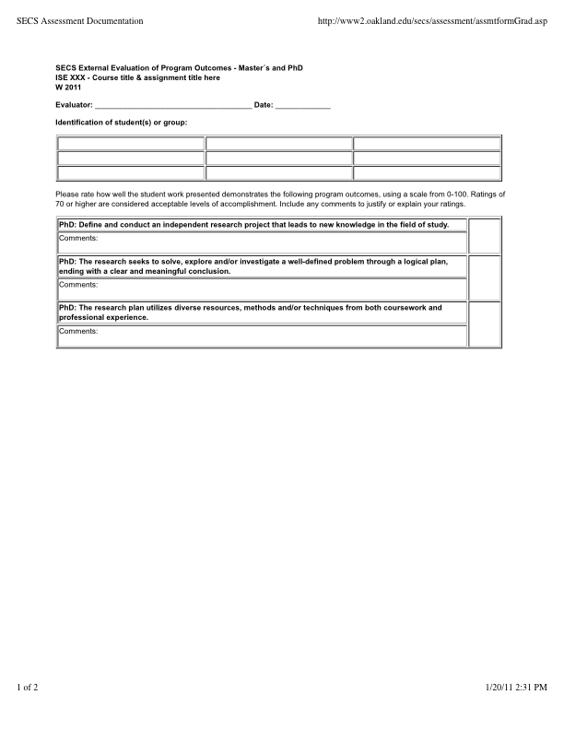

**Appendix A – Example External Evaluator’s Rubric**

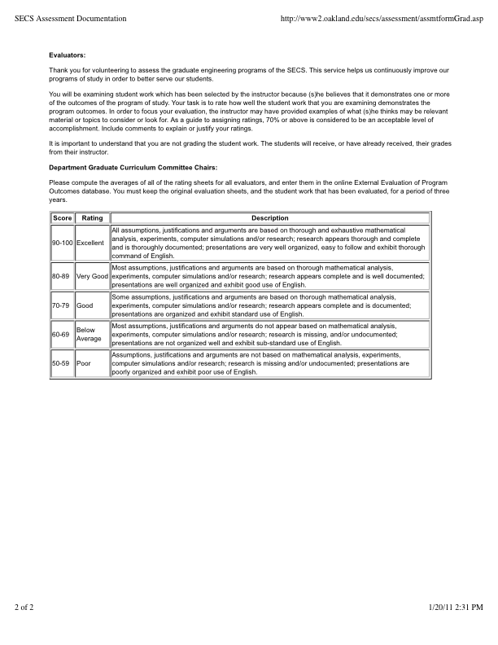

**Appendix B – Systems Engineering Ph.D. Alumni Survey**

1) Was your course work beneficial in the pursuit of your dissertation research?

2) Did the course work bring in the required breadth and depth in your knowledge base?

3) Have you been involved with the analysis or design of significant components or systems in your field, drawing upon your analytical skills and/or computer modeling expertise? If so, please give examples.

4) Have you been involved with the design and experiment of significant components or systems in your field? If so, please give examples.

5) Have you been involved with the adaptation or application of new technologies to engineering or computer science? If so, please give examples.

6) Have you produced any technical reports and made technical presentations in the last 12 months? If so, about how many?

7) Are your technical reports and presentations generally well received and understood?

8) How many papers have your published which were directly related to your dissertation work?

9) Please provide comments about your OU doctoral experience and suggestions for improvements.