Guidelines for entering data into Excel
- Put variables in columns and observation in rows.
  - Include a unique identifying number for each case.
- Put variable names in the first row.
  - Be sure that each variable name is unique (no duplicate variable names).
  - Variable names must start with a letter.
  - Do not include special characters (#, !, ?, %, parenthesis, etc.) or spaces in your variable names.
  - Variable names can include numbers, but the names cannot begin with a number.
  - Choose readily recognizable names for variables. Try to keep the length to ≤16 characters and they must be ≤32 characters. Avoid using underscore if possible. You can use camelCase to designate the start of a new word such as startDate instead of putting start_date.
  - Choose the name so if has something in common with the column.
- Use a separate column for each piece of information.
  - Don’t enter data such as "120/80" for blood pressure. Enter systolic blood pressure as one variable and diastolic blood pressure as another variable.
  - If you are collecting information such as height and it is measured in different units, put the numeric value in one column and the unit in another column. Other data like time measured in days, weeks, months years, etcetera also needs to be entered in two columns; don’t enter the data like ‘2 days’, ‘ 1 mo’, ‘5 weeks’, etcetera. For example, if someone is 65 inches tall, you would enter a 65 in the height column and a value of 1 in the heightUnit column where the value of 1 means that the height is in inches. If someone were 165 centimeters, then you would enter 165 in the height column and a value of 2 in the heightUnit column where 2 means the height is measured in centimeters. When data is only collected in feet and inches it is necessary to create two columns; heightFeet and heightInches. If someone was 5’6” you would put heightFeet=5 and heightInches=6.
  - For the questions where the respondent can select more than one response, don't enter the data as "A,C,D" or "BD". Include a separate column for each answer. For example, you might have four columns trtA, trtB, trtC, trtD and you would place a ‘1’ in each of the treatment columns that the respondent selected and a ‘0’ in those that treatment columns were not selected (you can also leave the 0’s out).
  - If a column contains lab values (or any type of variable), as well as entries such as “n/a”, “<0.1”, “could not be determined”, “undetectable”, or “>1000000”, it can be difficult to process the data. If you need to capture this type of data, enter it into a separate column from the numerical data.
- When entering dates (especially for years prior to 1930) include a 4-digit year.
  - Two digit years can cause problems for statistical software when reading data from Excel files. The best format for dates is mm/dd/yyyy, where mm is a 2 digit month, dd is a 2 digit day and yyyy is a 4 digit year.

- Decide on "missingness" conventions.
  - Missing data can cause a multitude of problems.
  - There are two options for entering missing data.
    - Leave the entry blank (the preferred method)
    - If you need to have a place holder for the missing data so you know that you have attempted to find the value and it was not attainable, you can enter an "impossible" numeric code (for numbers) or an easily recognizable single digit character code for character values (do not mix numeric and character data). Be sure, if you use a missing value code, that it cannot be confused with a "real" data value. A common value that is used to signify missing is 999 (or 9999 if 999 is a possible value).
  - Never have blanks imply ‘No’ and ‘Missing’ and ‘Unknown’. Code the ‘No’ as a numeric value (typically a ‘0’) and code the unknown as ‘8’ and leave the missing’s as blanks (or a ‘9’). Again, keeping in mind the codes you choose should not be possible data values.
- Use only one worksheet for your data.
  - If you decide to use multiple sheets for you data, follow the variable naming conventions for the tabs that name the sheets (keep the names simple and unique).
  - If an individual’s data is in many sheets, then you must have an identifier in each sheet so the data can be matched.
- Do not use "special" Excel features (i.e. hidden columns, filters, graphs on the data sheet that is your primary database, colors, italics, bold).
  - These features can be used on other separate "subset" or "analysis" spreadsheets that are for the investigator, but not the statistician or programmer.
  - Do not use colored cells, italics or bold to convey information; use separate columns instead. For example, to identify patient groups, use a column with a number for each group and include this information in your key (1=Group A, 2=Group B, etc.).
  - Software that is used to read in Excel data does not recognize filters that are applied to the data. If you only need a subset of the data analyzed, then you need to identify that data by creating a sheet with just that data in it or create a column with values to identify which rows you want analyzed. For example, create a row with the variable name ‘Exclude’ and put a ‘1’ in the rows that you don’t want analyzed.
- Summary statistics or results of preliminary statistical testing may be useful to reference, but these should not be placed in the same spreadsheet as the raw data. It is recommended that such results be placed in a separate spreadsheet or document (or they should be left out all together).
- Be extremely careful when doing sorting in Excel (or don’t do it at all).
  - Excel has as an unfortunate “feature”, the ability to sort a column independent of other columns. This means that it is extremely easy to completely scramble the data in a spreadsheet.

- Be consistent in your data entry
  - When entering data keep the same format throughout.

Good Example:

ID | DOB | Sex
1 | 12/31/1976 | F
2 | 01/01/1977 | M
3 | 01/02/1977 | F
4 | 01/03/1977 | F
5 | 01/04/1977 | M
6 | 01/05/1977 | F
7 | 01/06/1977 | M
8 | 01/07/1977 | M
9 | 01/08/1977 | F
10 | 01/09/1977 | F
Bad Example:

ID | DOB | Sex
1 | 12/31/1976 | f
2 | 1-Jan-77 | m
3 | 01/02/1977 | Female
4 | 01/03/77 | F
5 | 01/04/1977 | Male
6 | 01/05/1977 | F
7 | 1/6/77 12:00 AM | M
8 | 01/07/1977 | m
9 | 08-Jan-77 | F
10 | 01/09/1977 | f
Notice in the good example above that the date variable has the same format (mm/dd/yyyy) and the sex variable is consistent throughout in both case and type (character variable). In the bad example the date variable is in different formats without a 4-digit year for all the observations. The sex variable is still a character variable, but statistical software will read this variable as having six different levels instead of two.

- Document your database with a data dictionary and/or codebook.
  - Documenting your database will help the statistician, and yourself, the researcher, understand your data and database. It is a good idea to document what your variables are and what they mean. The data dictionary should include all of the variable names, a label or longer name that describes the variable including the units it is measured in, the codes for any categorical variables, and any notes for the variable. This should be a separate worksheet (i.e. sheet2) or document file.

Data Dictionary:
Variable Name | Description | Codes | Notes
id | Patient ID |  | Cannot have a missing value
treated | Treatment group | 1=’treated’  2=’control’ | Cannot have a missing value
age | Age (years)
race | Race | 1='White'  2='Black'  3='Middle Eastern'  4='Asian'  5='Native Hawaiian'  6='American Indian or Alaskan Native'  7='Hispanic'  8='Indian'  9='Other'  10='Unknown' | Code missing as unknown
sex | Gender | 1=’Female’  2=’Male’
height | Height |  | Blanks=missing data
heightUnit | Height Unit | 1=’cm’  2=’inches’
weight | Weight (kg) |  | Blanks=missing data
dm | Previous Medical History - Diabetes | 0=’No’  1=’Yes’ | Blanks=missing data
hyper | 'Previous Medical History - Hyperlipidemia | 0=’No’  1=’Yes’ | Blanks=missing data
procDt | Procedure date |  | mm/dd/yyyy
systolicBP | Systolic blood pressure |  | Blanks=missing data
diastolicBP | Diastolic blood pressure |  | Blanks=missing data
- When in doubt, ask the statistician.
  - Be sure the effort you are putting forth is necessary. The OUWB member should be able to tell you precisely what form the data needs to be in to suit its conversion and analysis.

Bad Data Set:
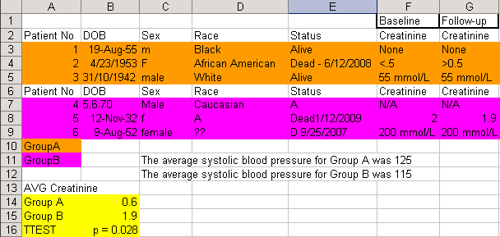

Better Data Set:
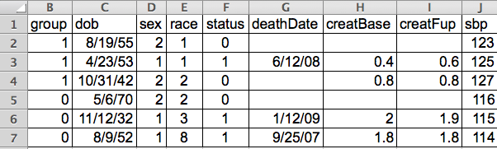

Key:
Variable Name | Description | Codes | Notes
id | Patient ID |  | Cannot have a missing value
group | Treatment group | 1=’treated’  0=’control’ | Cannot have a missing value
dob | Date of birth |  | mm/dd/yyyy
sex | Gender | 1=’Female’  2=’Male’
race | Race | 1=’African American’  2=’White’  3='Asian'  8='Unknown' | Code missing as unknown
status | Deceased | 0=’No’  1=’Yes’
deathDate | Date of death |  | mm/dd/yyyy
creatBase | Baseline Creatinine |  | Units=mg/dL
createFup | Follow-up Creatinine |  | Units=mg/dL
sbp | Systolic Blood Pressure

