**Vex-EDR Robotics Coaches/Teacher/Mentor Training**

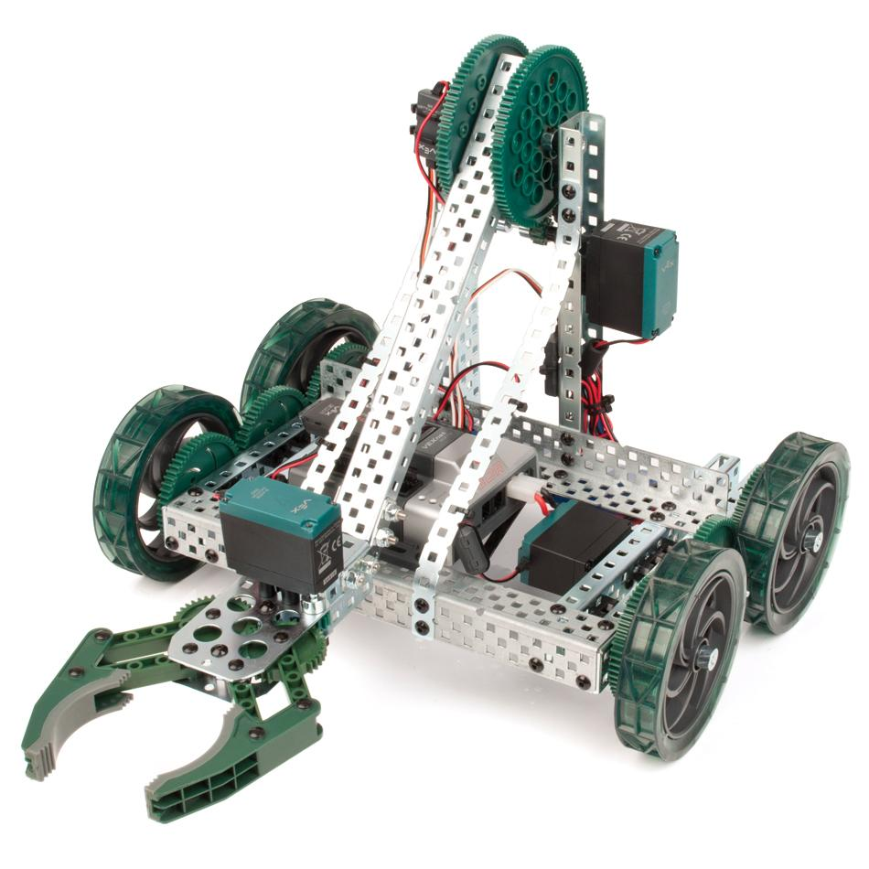

Date: August 13, 2016

Maximum Number of Participants: 25

Where: Engineering Center 360

Time(s): 8:00 am to 4:00 pm

Cost: $100

Description:

Participants will explore and create programs for a VexEDR robot using RobotC-Graphical interface.  *(For participants ready to go beyond the Graphical interface, the RobotC-Standard interface will be available.)* Using encoders, buttons, limit switches and distance sensors, the class will explore how to crate winning programs to compete in the Programming Challenge for Vex Competitions.  The programming skills will also be applied to assist drivers to more efficiently accomplish their team's tasks.

*(Gyroscopes will be available for participants who master the simpler sensors.)*

You must cancel before 2 weeks prior to the training to receive a refund.

