IRBNet for Researchers!
Step by Step Instructions

I. Glossary of Terms ………………………………………………………………………………………… 2
II. Register as an IRBNet User and Log-in for the First Time …………………………….. 6
III. Submitting Training Documentation and Creating a New Project ……………….. 9

A. Training Documentation/Credentials on IRBNet ……………………………… 9
B. Creating a New Project ……………………………………………………………………. 9
C. Attaching a Document ……………………………………………………………………. 11
D. Delete, Edit or Replace Documents Once Attached …………………………. 14
E. Sharing the Project with other Key Personnel …………………………………. 17
F. Signing the Project Package …………………………………………………………….. 19
G. Submitting the Project Package .……………………………………………………… 20

IV. Delete a Package before Submission ………………………………………………………….. 22

V. Send Project e-Mails ………………………………………………………………………………….. 23

VI. Submitting a Revision in Response to an Administrative “Pre-review” ……….. 25

VII. Submitting a Revision in Response to IRB “Review”………………. …………………… 25

VIII. Submitting New Packages: Amendments, Continuing Reviews, etc. ………….. 35

I. IRBNet Glossary of Terms

In an attempt to help standardize the online review of Human Subjects research applications, Oakland University will adopt the naming logic used by IRBNet. In most cases these are terms that have widespread acceptance by Institutional Review Boards and are used by the United States Department of Health and Human Services. Please take a few minutes to look at the following glossary. It may make it a little easier to navigate the IRBNet waters.

Project
A Project is an online version of the research proposal/protocol being submitted to Oakland University’s IRB for review. Once a Project has been created, all subsequent submissions are submitted through the same Project.
Project Package
A Project Package, or just “Package”, is a submission containing any number of documents that are required by the IRB to conduct their review of a research Project. The Project Package for a new submission will include the appropriate Human Subjects Research Application, the full research proposal, the research funding proposal, if applicable, any surveys or instruments, consent forms, any advertisement or recruiting materials, a Conflict of Interest Disclosure Statement form from ALL Key Personnel listed on the Project and any other documents requested by the IRB (See the first page of each submission application for a more detailed list of submission materials). Subsequent Project Packages will contain revisions to one or more documents that were submitted in the original Project Package and/or new documents that were not submitted in the original Project Package. The revised and/or new documents in these subsequent Project Packages will be based on requests/responses received from the IRB. Continuing reviews, amendments to approved Projects, event reports, etc., should also be submitted as new Packages to the existing Project and labeled appropriately. Please note that these documents should not be submitted as a new Project.

A six digit number is assigned to each new Project that is submitted to the IRB for review through IRBNet. Each six digit number is followed by a dash and the number after the dash indicates the Package number for that Project. There may be many Packages associated with each Project. For example, 123456-1 means that this is the first Package for the Project; 123456-2 indicates the second Package for the Project, etc. Examples of submissions that would require the submission of additional Packages to an existing Project include revisions requested by the IRB, amendments, continuing review applications, event reports, etc.
Submission
IRBNet uses the term Submission to denote a total Project Package that has been submitted for official review.

Researcher
A Researcher is the individual submitting the Project for IRB review. There are three Researcher categories that will be used by IRBNet:
- Oakland University Faculty Researchers
- Oakland University Student Researchers
- Oakland University Staff Researchers

Principal Investigator
IRBNet uses the term Principal Investigator (or PI) to designate the person with overall responsibility for studies submitted by Oakland University Student researchers, Oakland University Faculty researchers and Oakland University Staff researchers.

Amendments
Amendments are changes that the researcher wishes to make after a study is approved by the IRB. The researcher will use an Amendment Form to make changes to previously approved studies BEFORE the IRB approval period has expired. Researchers must submit an Amendment Form and any additional documentation as a new Project Package to the existing Project in IRBNet for IRB approval. This package number will consist of the five digit number assigned at the time the initial application was submitted, followed by the package number.

Revision
A Revision is a change (or changes) required by the IRB before a Project can be approved. The researcher creates a new Project Package (NOT a new Project) in IRBNet to address any revisions required by IRB members. Alternatively, Packages may be unlocked for revisions that are requested by IRB Administrative Staff. In the latter case, revisions are addressed within the same Project Package.

Reviewer
A Reviewer is an IRB Board member or designee that is involved in the review of a Project.

Pre-review
Administrative review for missing submission requirements prior to assignment of the study to an IRB member for review.
Type of Reviews
The Type of Review is the level of IRB review the researcher is requesting for their Project. Please note that the Oakland University IRB follows the naming convention used by IRBNet and the Office for Human Research Protections (OHRP) to categorize the type of IRB review. The three levels are Exempt, Expedited and Full Committee Review.

Exempt: Proposals are exempt from federal regulations and more detailed review if the research described poses no more than minimal risks (risk level similar to what is encountered in everyday activities) to subjects and proper procedures are used to implement ethical principles for the protection of human subjects. The IRB chair or designee of the IRB chair determines whether a research project will undergo an exempt review. As necessary, the IRB chair or designee will consult with other IRB members when making this decision. The following types of research may fall into the exempt category (See 45CFR46 or Oakland University IRB guidelines for a more detailed description of OHRP Exempt Categories):

- Survey/interview procedures or observation (without intervention) of public behavior
In which disclosure of this information would NOT reasonably place the participant at risk of criminal or civil liability or be damaging to the participants’ financial standing, employability or reputation.
- A project using existing data or pathological specimens provided the information is recorded anonymously.

Expedited: The expedited review category is used for certain types of research involving no more than minimal risk, as well as for minor changes to research previously approved by the full committee during the period for which approval has not expired. Proposals can be reviewed by one or more members of the University's IRB. Reviewers may refer the proposal to the full committee. The following types of research may fall into the expedited review category (See 45CFR46 or OU IRB guidelines for a more detailed description of OHRP Expedited Categories):

- Surveys which can be linked to participant and may request "sensitive" information;
- Blood draws;
- Non-stressful research on individuals or group behavior;
- A project using existing data or pathological specimens if the information recorded can be linked to participant;
- Recording of data using non-invasive procedures

Full Committee Review: Any research not covered under the exempt or expedited review categories is referred to the IRB for full committee review. The PI may be invited to attend the IRB committee meeting. The committee will either: (i) approve the research as written or pending specific minor changes; (ii) require modifications to secure approval; or (iii) not approve the research. The committee will notify the principal investigator in writing about the committee's decision. The following types of research may fall into the full committee review category:

- Invasive medical treatments;
- Physical or psychological risk;
- Special populations (minors, pregnant women, prisoners, incompetent participants); and/or
- Surveys which can be linked to participants and may request “sensitive” information

Required Signatures
The Required Signatures are captured on each of the IRB submission forms. Required signatures include those of the PI and Department Chair. If the PI is a student, the student’s Faculty Advisor MUST also sign the application. If the PI or Faculty Advisor is also the Department Chair, the Dean of the School must sign the application form.

The PI must also electronically sign the package prior to submission to the IRB. If the PI is a student, the student’s faculty advisor must also electronically sign the package.

PLEASE NOTE THAT IF THE SUBMISSION IS MISSING ANY REQUIRED SIGNATURES, THE PROJECT WILL NOT BE REVIEWED.

Review Status
IRBNet uses the following terms to denote the status of studies submitted for review.

Acknowledged: The committee or office acknowledges the receipt of the information.

Approved: The submission has met the IRB criteria for approval.

Approved with Conditions: The committee requires specific minor changes to the submission to secure approval.

Exempt: The submission is exempt from IRB review in accordance with federal regulations.

Modifications Required: The committee requires changes to the submission to secure approval.

Pending Review: The submission is awaiting committee review.

Not Approved: The concerns of the committee are substantive in content and the IRB criteria for approval have not been met.

Not Research: IRB member or IRB administrative staff has determined this project does not meet the federal definition of "research" under the purview of the IRB.

Not Human Subjects Research: IRB Member or IRB administrative staff has determined this project does not meet the definition of “human subjects research” under the purview of the IRB.

Work in Progress: The Project has not yet been submitted to an IRB for review. The
Project can be managed and edited without generating a new IRBNet ID number.

Researchers will be updated on the review status of their submission through an e-mail notification generated through IRBNet.
Permissions
Permissions are levels of access that a researcher grants to IRBNet users. Different levels of access may be given to co-investigators, faculty advisor(s) or key personnel. Permission is given to others by “Sharing this Project.” The “Sharing this Project” option tab can be found on the Submission Detail page. IRBNet allows the following levels of access.
Full: The individual may manage and control all aspects of the Project (e.g., write, share, submit, edit, etc.). For instance, a PI may want to give another individual full access to the Project if that individual will be involved in making edits to the Project or submitting the Project to the IRB.

Write: The individual may collaborate on Project documentation, but may not share the Project with others, submit packages for review, or take certain other actions reserved solely for the Project owners.

Read: The individual has read only access to the Project.

All access levels have the ability to electronically sign a Project Package where necessary by clicking on Sign this Package under Project Administration on the Submission Detail page.
Researchers, administrators or others must be registered in IRBNet in order to be granted any level of access.

Project Mail
Project mail is used to communicate with IRB committee members, IRB administrative staff or other members of the project team who have been given access to the Project. Please note that project mail is sent to the individual’s registered e-mail account. Researchers or others should not respond to project mail through regular e-mail, but should log into IRBNet, open up the message under the Messages and Alerts tab and “reply” to the message. An audit trail will be lost if the researcher responds through regular e-mail. The project mail tab is located under Project Administration on the Submission Detail page.
Reviews
Board Documents (i.e. Approval letter, Modification letter, date-stamped consent documents etc.) are
communicated to researchers under the Reviews tab which is located under Project Administration on
the Submission Detail page. It should be noted that date-stamped consent documents (Adult Consent, Child Assent, and/or Parental Permission) should be downloaded and saved by the researchers to be used in recruitment and consent of participants.
Project History
Project history is a summary of all packages submitted under a Project. Project History is used to create a New Package for the Project by clicking on Create New Package button.
II. Register as an IRBNet User and Log-in for the First Time

1. Go to http://www.irbnet.org

2. In the upper right-hand corner of the screen, under the login boxes, click on “New User Registration.”
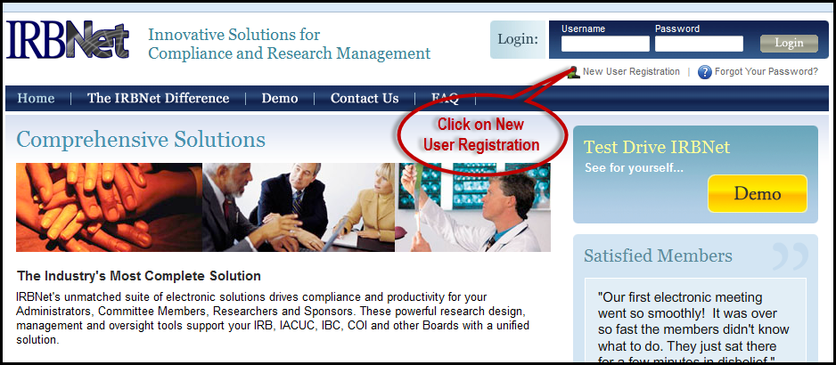

3. Fill in your first and last name, create a user name and password, and then click “Continue.”
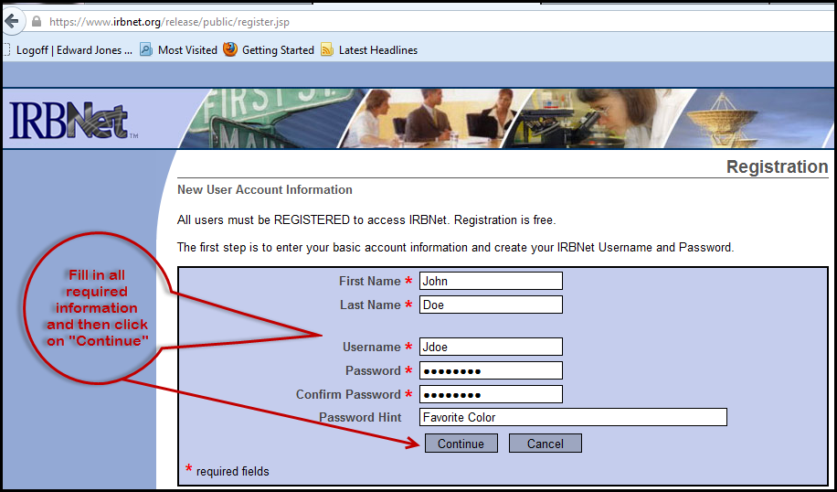

4. On the next screen about “Terms and Conditions” please read and then click “Accept.”

5. To add your institutional affiliation, in the box “Search for an Organization” (#1 in the screen shot below) type in “Oakland University”. Make sure “Research Institution” (#2 in the screen shot below) is selected. Click the “Search” (#3 in the screen shot below) tab, and then click “Continue.”(#4 in the screen shot below)
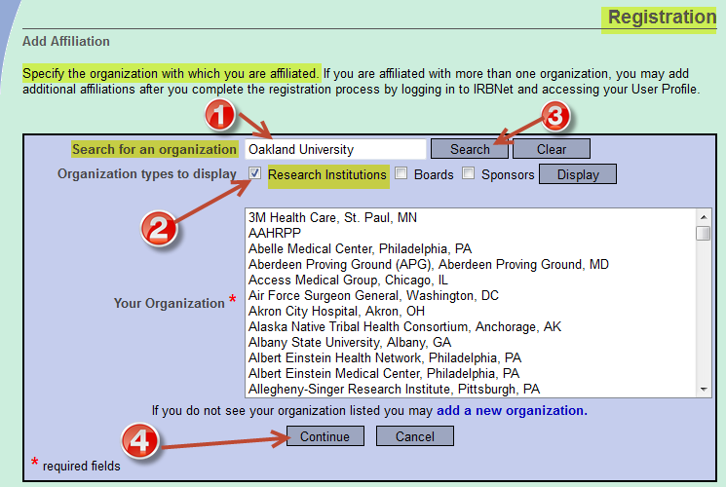

6. Alternatively, you may search for the University with which you wish to affiliate. The example below shows “Oakland University” as the affiliated or selected institution.
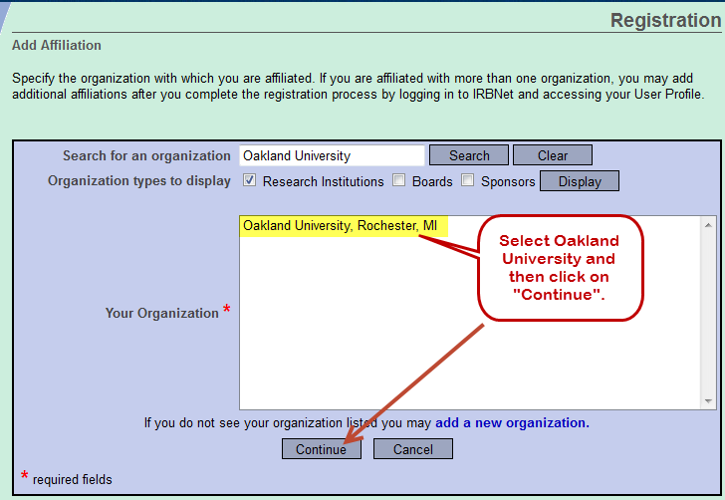

7. Next you will see the “Registration Screen.” Enter your contact information in all the required fields and click “Continue” to register with IRBNet.
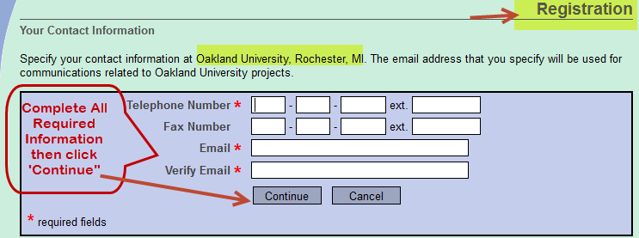

8. You will then receive an e-mail from IRBNet with the subject “Activation Required.” Go to your e-mail and click on the link or copy and paste it in your browser. Return to the IRBNet website. Log-in with your “User Name” and “Password” to authenticate your registration.
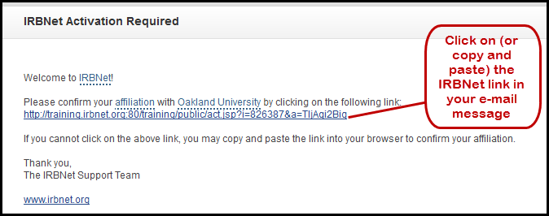

9. Please note that after you have completed registration, all others who want or require access to the Project (i.e. faculty advisor for student researcher) must register in IRBNet. Access to the Project is granted through sharing the Project (see “Permissions” under IRBNet Glossary).
Congratulations! Now that your IRBNet account is activated, you may log back in to IRBNet to add your training documentation or other credentials and begin creating a new research Project!
III. Submitting Training Documentation and Creating a New Project

NOTE: All Investigators and Key Personnel MUST complete or have current CITI training BEFORE a project application can be reviewed by the IRB. CITI training can be accessed at https://www.citiprogram.org/ .

A. Training Documentation/Credentials on IRBNet
All new IRB submissions require documentation of CITI training. Documentation of CITI training can be submitted in IRBNet by uploading the CITI completion report.

To submit documentation of your CITI training or other credentials, log in to IRBNet. Click on “User Profile” at the top of the screen. Under “Training and Credentials” select “Add a New Record.” Follow the instructions on the screen to upload your completion report. Once you have identified the required training document, click on “Submit” to upload it into IRBNet. You may attach additional credentials (e.g., CV) as needed. Please note that once these training and credentials records are uploaded into IRBNet, they can be linked to any subsequent new project submission. Please see step III. D. 21 below for details on how to link credentials to a specific Project.

B. Creating a New Project

After your training credentials have been uploaded into IRBNet, the following steps should be followed to create a new Project.
1. Log into IRBNet.
2. In the blue menu bar on the left-hand side of the “My Projects” page, choose “Create New Project.”

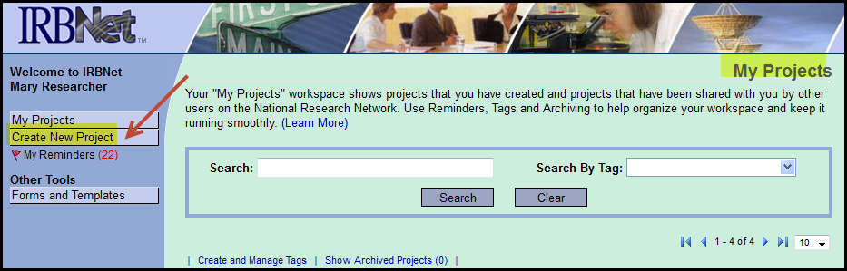

3. Fill out all “Required Fields” and click “Continue.” Entering Keywords is optional. If your Project will be sponsored research (e.g., NIH), enter the sponsor's name.
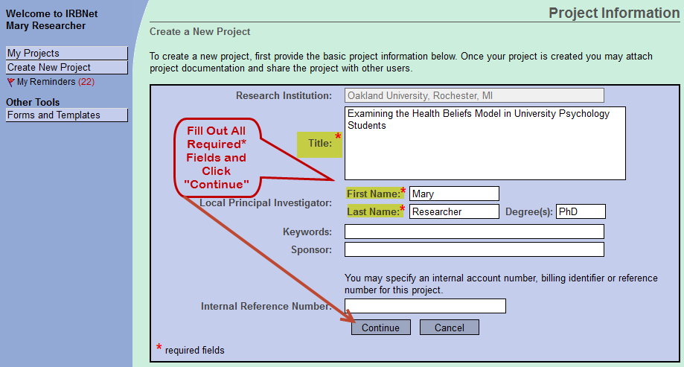
4. Next you will see the “Designer” page. Under Step 1, click on the dropdown arrow to view the IRB documents that may be necessary in submitting your application package. Select a document from the dropdown menu and click “Download.”
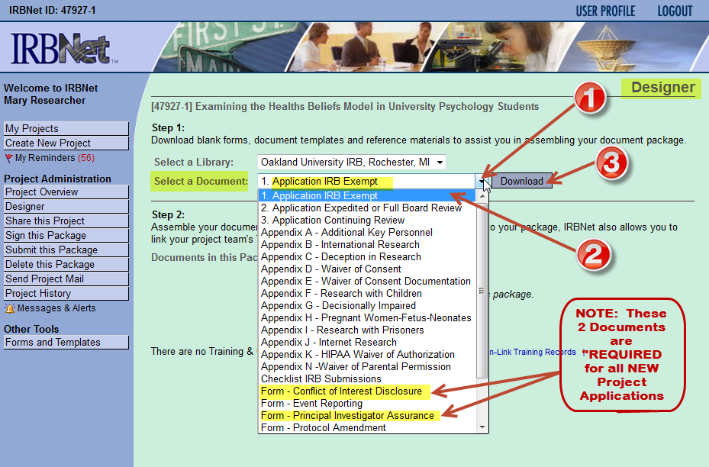

5. Save the document to your desktop or a folder you have created for this Project. You can only download one document at a time. Note: A “Conflict of Interest Form” is required for the PI, all “Key Personnel” and the faculty advisor/faculty sponsor, if applicable, on the Project. Key Personnel is defined in the Exempt and Expedited/Full Board Applications. PI Assurance Form is no longer needed.

6. If you discover that you need an additional document (e.g., Appendix D – Waiver of Consent) while filling out the downloaded application, simply log back into IRBNet, and click on “Forms and Templates” on the left-hand side of the screen in the blue menu bar. You will see the dropdown of available documents again. Select the document you need, download it and save it to your desktop or project folder.

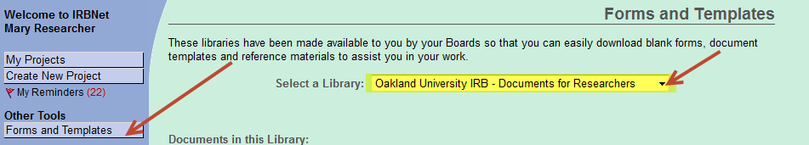

C. Attaching a Document

7. Once you have completed the IRB application and all the required forms, you are ready to upload the forms to IRBNet.

8. Log into IRBNet.

9. On the “My Projects” page, click on the Project you wish to add documents to. In this case, we are working with the Project titled “Examining the Health Belief Model in University Psychology Students.”

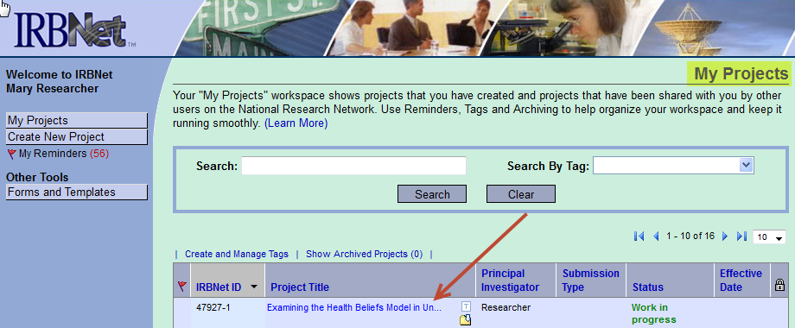

10. The following “Project Overview” screen will appear (see screenshot on the next page). On the left hand side of the screen, click on “Designer.”
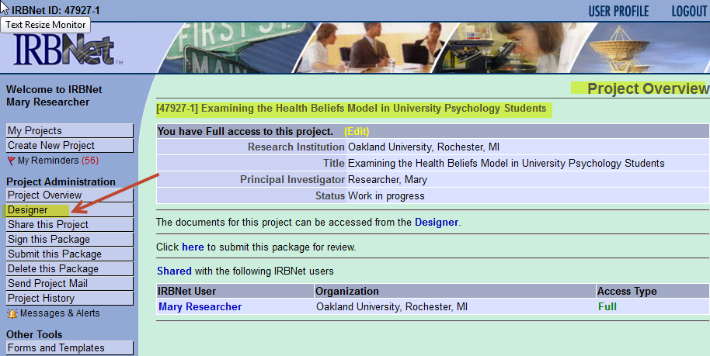
11. Once you have opened the “Designer” page, under step 2, click on “Add New Document.”

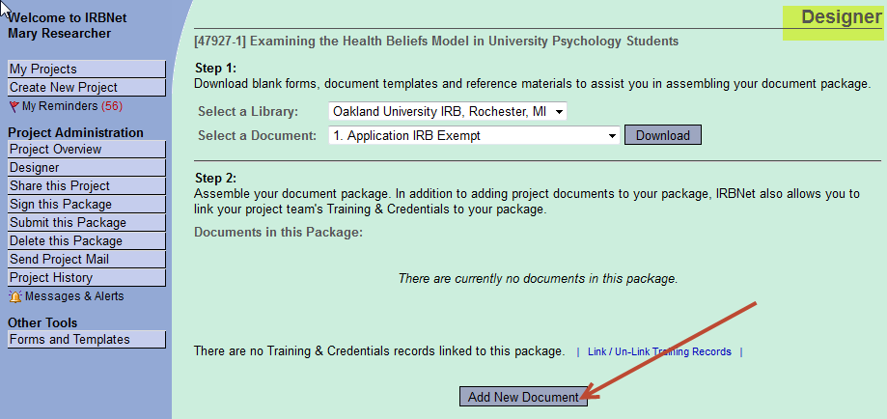

12. As shown in the following screenshot, on the “Attach Document” page, click on the drop down arrow to view the type of document you wish to upload. Select the document type.

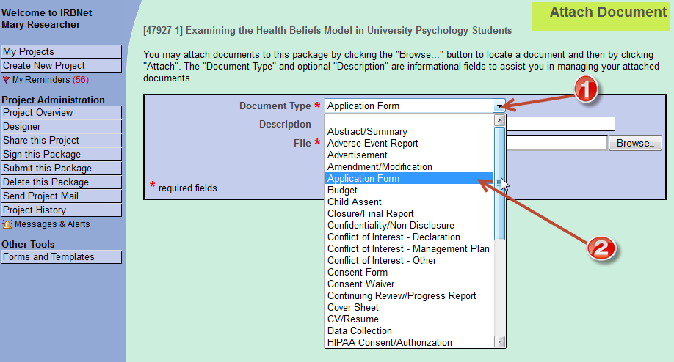

13. In the “Description” field, type in a brief description of the document you are attaching. Next, click the “Browse” button to locate the document you wish to attach to your Project Package.

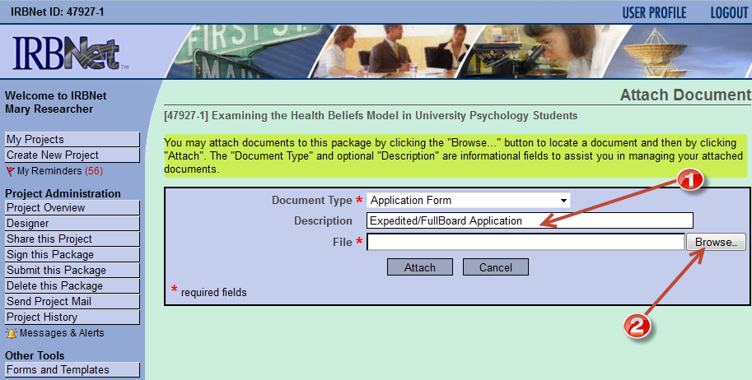

14. Once you have located the file on your computer, select it from your computer and click “Attach” at the bottom of the screen.

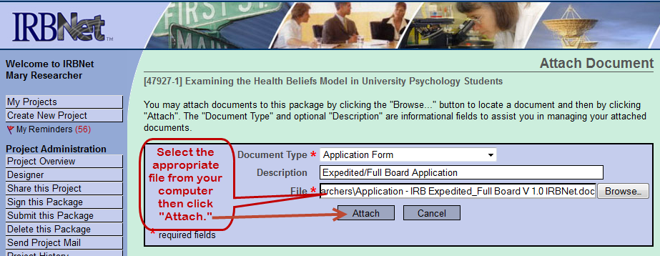

15. The application is now attached to your Project in IRBNet. Continue this process until all required forms are attached to your Project.

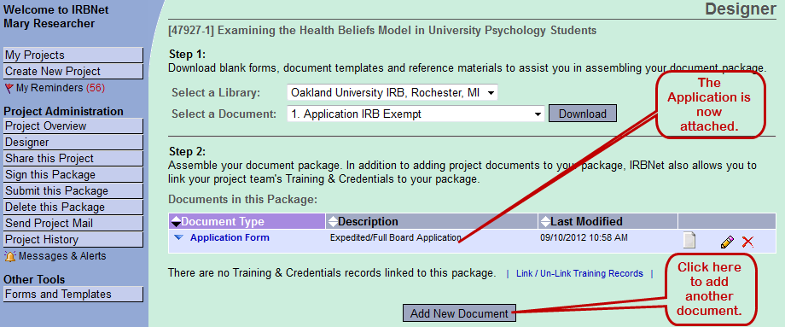

D. Delete, Edit or Replace Documents Once Attached

OOOPS, I MADE A MISTAKE!!!

Before submitting your Project, there are three methods to modify the documents you have already attached to your "Project Package:" A) "Delete" an attached document, B) “Edit" a document, or C) "Replace or Overwrite" an attached document.

16. A) “Delete” an Attached Document: There will be occasions when you will want to remove an attached document from your Project Package altogether. Click on the Red icon to delete a document. A dialog box will appear asking if you want to delete this file.

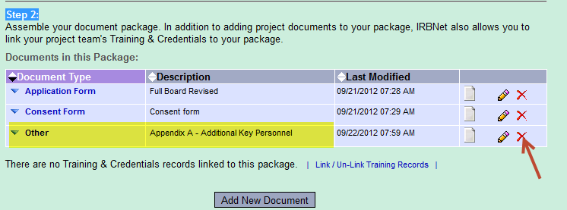
17. Below is the dialog box. Once you click the "OK" button, the file is gone forever from the Project Package or until you re-load it.

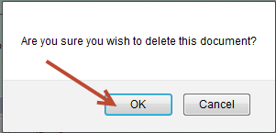

18. B) “Edit” a Document: To edit a document that that has already been attached to your Project Package (in this example we will select the “Consent Form”), click on the document you wish to edit . Your document will appear. Make the changes to the document and then save it to your desktop or project folder. (You should create a different file name on your desktop or in your project folder to keep a history of what you submitted.) Next, delete the old document you wish to replace by using the RED and then upload the “New Document” as in step 11. Researchers usually “Edit” a document when there are only minor changes to a document and the researcher wishes to use the original document they submitted.

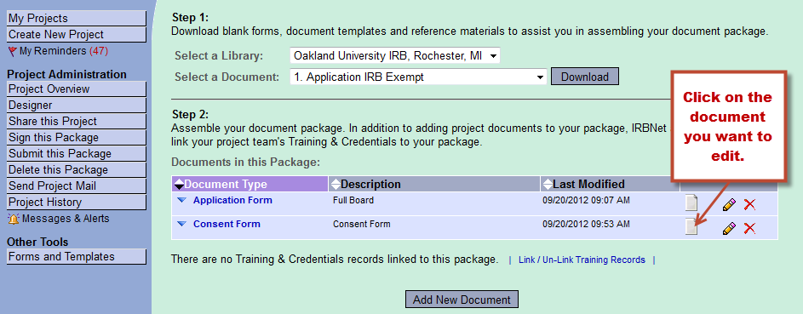

19. C) “Replace or Overwrite” a Document: In some instances you may also wish to just "Replace or Overwrite" a document you have attached. For example, let's say you attached a "Consent Form" but you realize you attached the wrong consent form, one from a different study. The "Pencil" Icon will allow you to simply overwrite the attached form with the correct form without having to delete it and upload it again. This can only be done prior to submitting the Project Package.

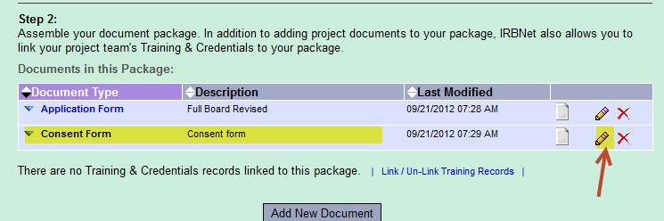

20. Click on the "Pencil Icon" . You will see the following screen.
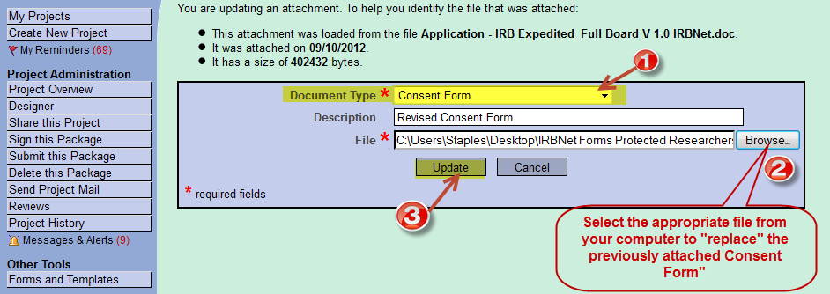
Select the “Document Type” from the drop down menu. Next click the "Browse" button. Locate the file on your computer you wish to "Replace or Update." Click on "Update." Note: this function replaces the file previously attached with the new file you have selected.
21. Link training records/ credentials to the project
Once all documents have been added to IRBNet, be sure to link your training records/credentials to the Project. The link to training records can be found at the bottom of the Designer page. Click on “Link Training Records” (in blue).
E. Sharing the Project with other Key Personnel
22. Now that you have attached all the required documents, you may share access to this Project with other members of the research team. All other members of the research team must have registered in IRBNet in order for you to share the Project with them.
- If you are NOT the PI for this Project, it will be necessary for you to share the Project with the PI.
- If you are unaffiliated with Oakland University, it will be necessary for you to share the Project with the Oakland University faculty sponsor for your Project.
- If you are a student, you must share the Project with your faculty advisor in order to obtain their electronic signature.
- Signatures of the PI, department chair, faculty advisor, and dean, as applicable, must be captured on the submission application. However, each person signing for the Project is expected to have read the application and reviewed the other submission documents. Thus, it is essential to have shared the Project with all individuals whose signature will be obtained.

In order to “Share” the Project, click the “Share this Project” button on the left-hand side of the screen. The following screen will appear. In most cases you will choose the “Share” option rather than “Multi-site” or “Transfer” option. Click on the “Share” link, the first option.

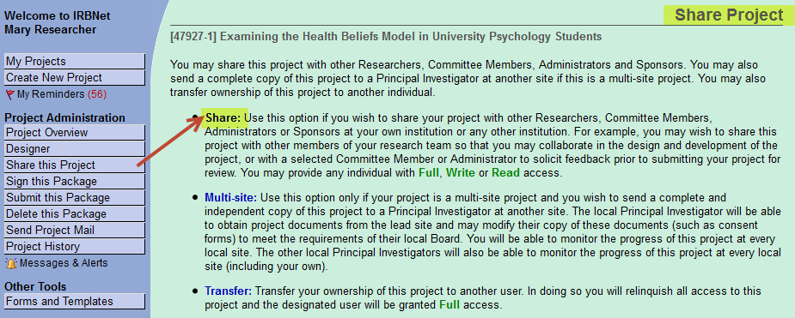

You will be taken to a screen where you will be asked to select an organization where the individuals you wish to share your project with are located. From the drop down menu, select “Oakland University.”

NOTE: Before you can share the Project, the person you wish to share it with MUST:
- Register with IRBNet https://www.irbnet.org
- Complete the “User Profile”
- Affiliate with Oakland University (unless a Co-PI is located at a different institution)
- Reply to the IRBNet e-mail to complete registration.

23. In the “Search Bar” search by name for the individual you wish to share the Project with. Select the level of access you wish to grant to the individual under “Permission Access”. The levels of access are: “Full, Write or Read.” The default option is “No Access.” Continue the process until you have given access to as many individuals as you wish.
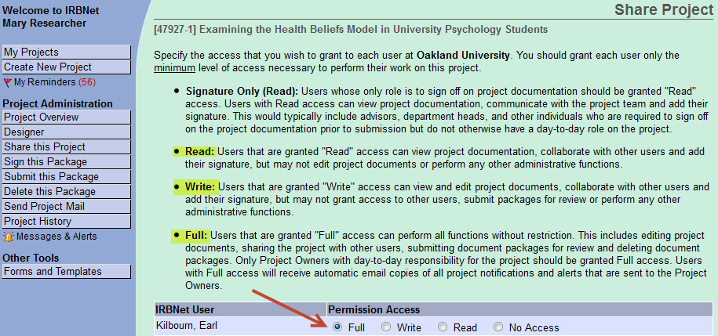

F. Signing the Project Package

24. It is time to electronically “Sign” the package preparing it for submission. The “Sign Package” screen allows IRBNet users with access to a Project to record that they have read the Project’s documents in their entirety and agree that they are ready for submission to the IRB for review. From the “Project Overview” page, click on “Sign this Package.” The “Project Overview” page appears each time a Project is opened in IRBNet.

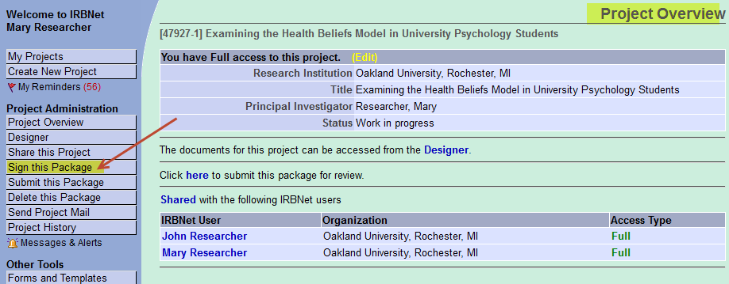

25. On the next screen, use the drop-down box to view and select your role in the project. Click on your appropriate role, and then click “Sign.” In this example, Mary Researcher is a student and the PI and has shared the Project with her faculty advisor "John Researcher". Mary is signing as the Principal Investigator on the Project.

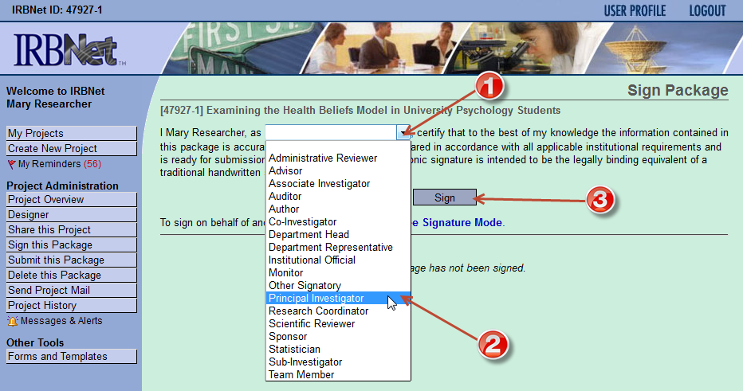

G. Submitting the Project Package

26. The “Submit Package” page is where you will deliver your completed Project Package to the IRB for review . On the “Project Overview” page click on “Submit this Package.” This will take you to the “Submit Package” page.

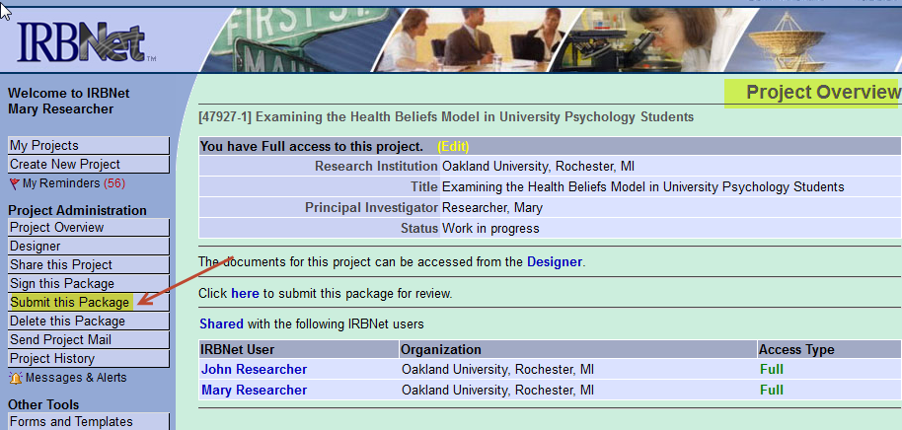

27. On the “Submit Package” page, ensure that “Oakland University IRB, Rochester, MI” is selected, and then click “Continue.”

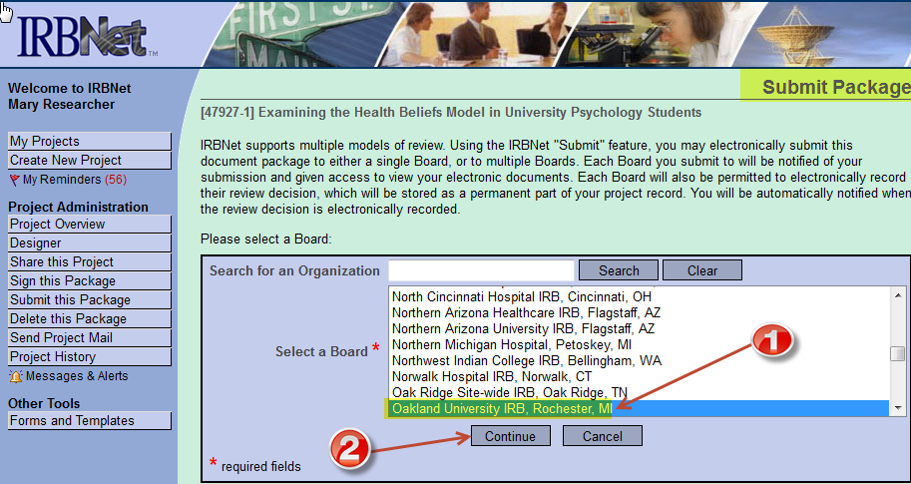

28. After clicking “Continue” you will be taken to the following screen. Click on the drop-down menu next to “Submission Type.” Select the appropriate option. In this case the PI is submitting a “New Project” that has not been previously approved by the IRB. The PI, therefore, selects “New Project” as the “Submission Type.” You may also add comments to the IRB in the comment box if you choose. This is optional.

29. The last step is to click on the “Submit” button. NOTE: Once you have submitted your Package, it CANNOT be deleted! If you wish to “DELETE” the Package for any reason, it MUST be deleted BEFORE you click on “Submit.”
See the following section (IV. Delete a Package before Submission) to “Delete” a Package.
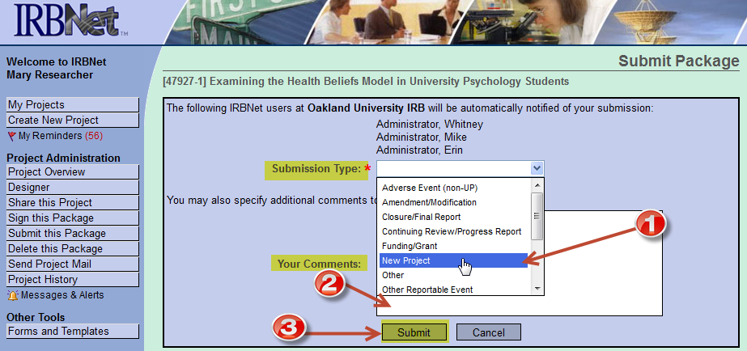
That is it! You have completed all the steps required to register, log-in, and submit a new study in IRBNet!

IV. Delete a Package before Submission

Deleting a Project Package before submitting it to the IRB for review is simple but as noted above, it MUST be done BEFORE you click the “Submit” button.

1. Logon to IRBNet. You will be taken to the “My Projects” page. Click on “My Projects” on the left-hand side of the screen. A list of your Projects will be provided. Click on the Project you wish to delete. In this example we are going to delete the Project we have been working on: “Examining the Health Belief Model in University Psychology Students.” Note: in the title bar the “Status” of the Project reflects that the Project has not been submitted; it is still a “Work in Progress.”

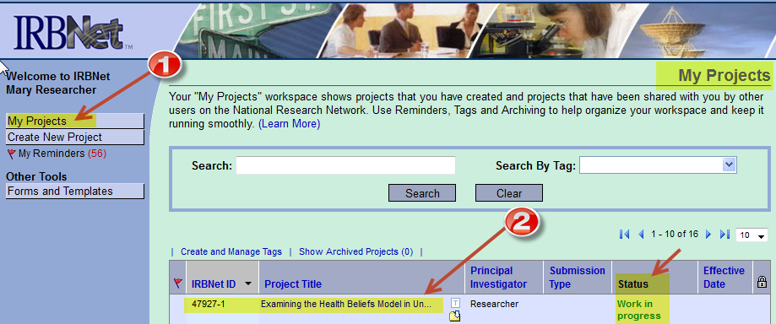

2. Once you have clicked on the Project you wish to delete, the “Project Overview” screen will appear. Click on “Delete this Package.”

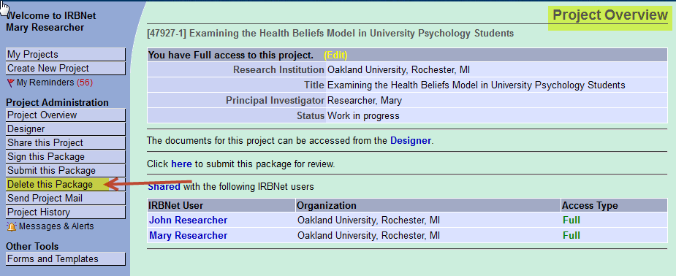

3. On the “Delete Package” screen, click on “Delete.” The project package will be deleted. Note the “Warning” and make sure you want to permanently delete the project package.

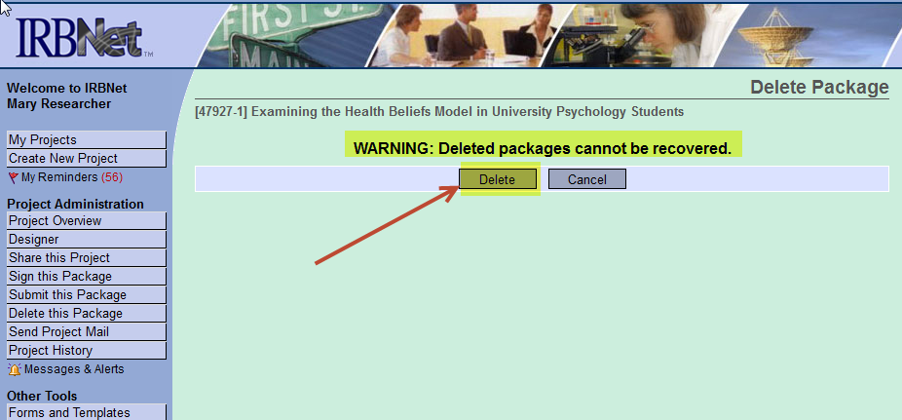

V. Send Project e-Mails
The “Send Project Mail” function allows members of the research team to send e-mails without leaving IRBNet and helps to organize e-mail correspondences relating to a Project. IRB members can also send Researchers e-mail via this function. If you do this, you MUST also send the e-mail to the IRBNet Administrators.

1. Log in to IRBNet. From the “My Projects” page, click on the Project about which you wish to send an e-mail to research team members.

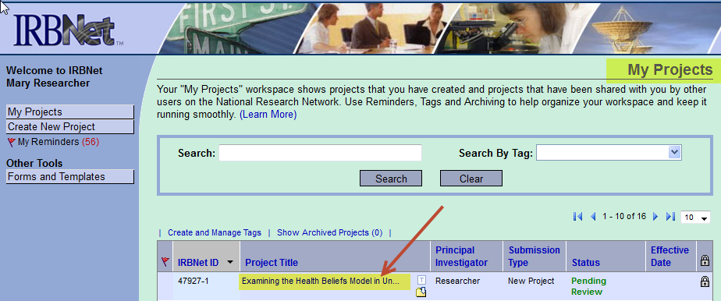

2. On the “Project Overview” page (under “Project Administration”), click on the “Send Project Mail” button.
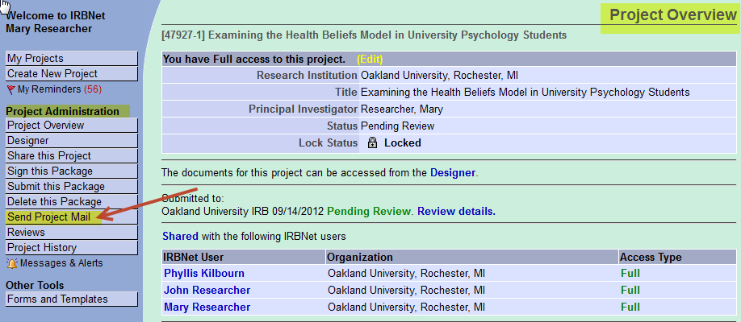

3. Select e-mail recipients. Type a message in the box and click the “Send” button.

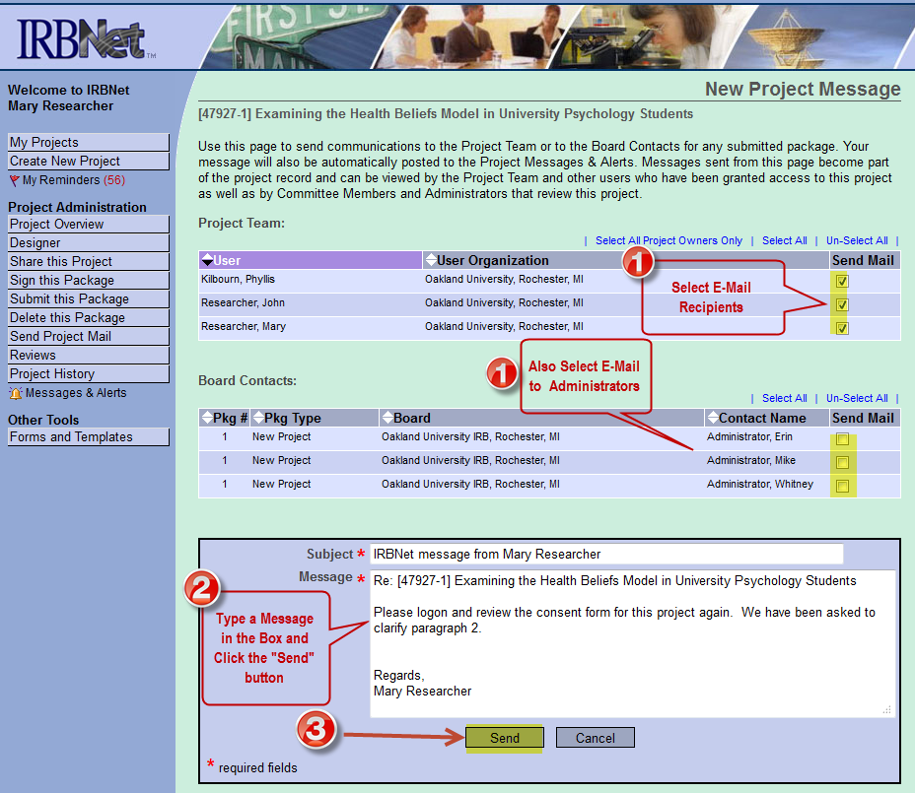
VI Submitting a Revision in Response to an Administrative “Pre-review”

Once a Project has been submitted to the IRB for review, IRB administrative staff will conduct an administrative pre-review of the Project to ensure completeness of the Package. The IRB administrator’s pre-review will be sent to the researcher by “unlocking” the Project Package. When a Project is unlocked, documents can be added, deleted, or revised, but will be retained in the same project package. An audit trail of documents is not maintained when revisions are made to an unlocked package. Revisions to the administrative pre-review are submitted to the IRB administrator by locking the project package after revised documents are uploaded. Packages are locked by clicking on “Mark Revisions Complete.”

VII. Submitting a Revision in Response to IRB “Review.”

After your Project has been submitted to the IRB for review, you may have to make one or more changes to your Project before the IRB can grant approval or concur an exempt determination. For exempt studies, revisions are usually accomplished by unlocking and locking the Project Package. For expedited and full board review studies, revisions are made by creating new Project Packages. Creating a new “Project Package” in IRBNet enables you to make revisions to your original “Project Package” and track changes throughout the IRB review process. If revisions are needed, you will receive a notification in your registered e-mail account that a Decision Letter document has been published. You will also receive another e-mail notification that a modifications letter has been attached under Board Documents in the Reviews section of your IRBNet submission. The modifications required letter details all required revisions that must be made to the submission in order to secure approval. See the example letter below. The required modifications should be submitted as soon as possible to ensure timely review and approval of your Project.
In addition to making the requested modifications, the researchers must respond to the requested revisions by preparing a detailed response to each action item and uploading it to the Project Package as detailed above.

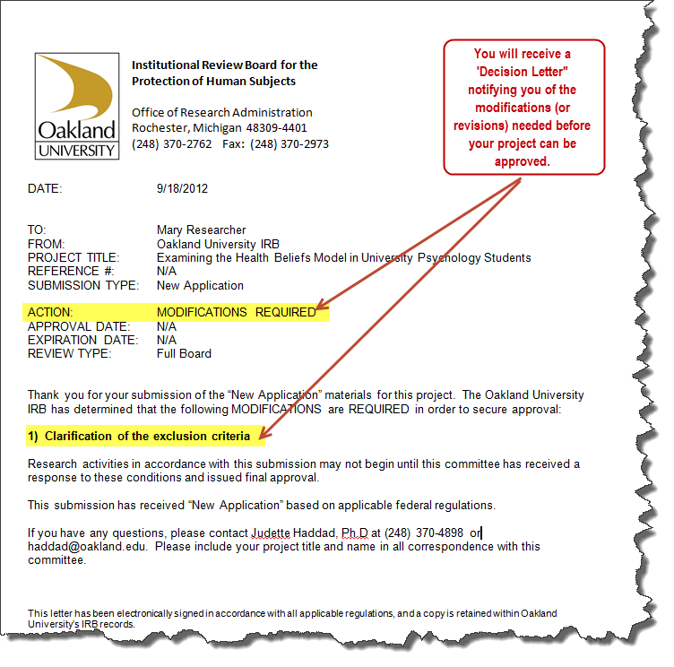

1. To submit a revision in response to the Modifications Required letter, log in to IRBNet. The “My Projects” screen will show “Modifications Required” under the “Status” column. Click on the Project that requires modifications.

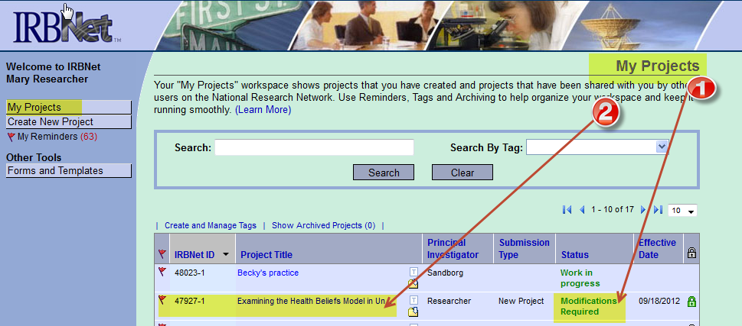

2. You will then be taken to the “Project Overview” page. Click on “Project History” on the left-hand side of the screen. You will be taken to the “Project History” page.

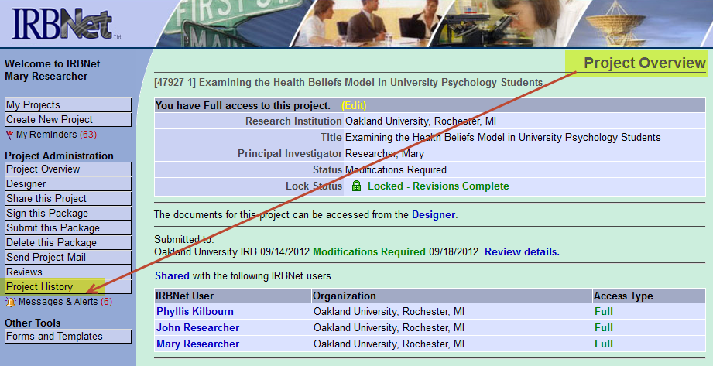

3. On the “Project History” page click on “Create New Package.”

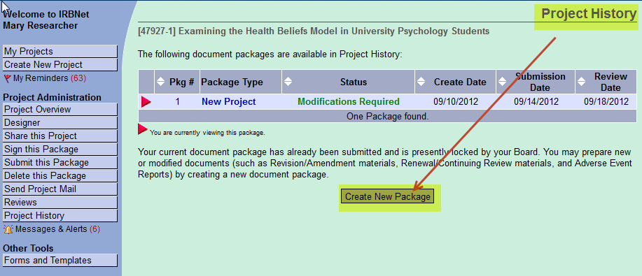

4. Notice on the “Project History” page that a “NEW Document Package” has been created when the “Create New Package” option has been clicked (See arrow number 1 in the screenshot below). IRBNet uses the same project number (47927 in this example) but changes the package number from 1 to 2 (47927-2 as shown in arrow number 2). This allows for all revisions in a submission to be tracked. The status of this new Project Package is “Work in Progress” as shown by arrow number 3. Do NOT confuse a “New Document Package” with a “New Project”. There may be many “Packages” associated with each Project. For example: when a continuing review application is submitted for a specific study/protocol, a “New Package” will be created and submitted under the existing Project.

Click on "New Document Package” to begin the process of modifying your Project Package. You will be taken back to the "Designer" page.

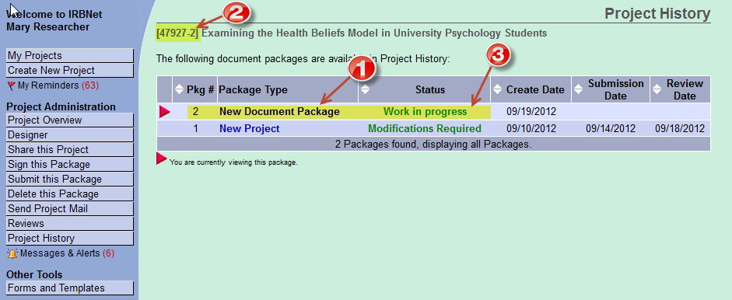
5. The "Designer" page will show information for the "New Document Package." From this page you can either “Add New Document” if you have a new document to add that was NOT previously submitted (for example: a new questionnaire) or update a document submitted in a previous Project Package.
There are two options on the “Designer” page to add documents to the "New Project” package. The following helps to clarify when to use these options.
Add a New Document. Use the "Add New Document" button option when the document you are adding is NOT a revised or updated version of an existing project document. The "new" document will not be tied to the Document History of any existing document, and it will not have any Document History of its own since it is a completely new addition to your Project.
Revise an Existing Document. Use the "Pencil Icon" option when you want to add a new version of an existing project document. IRBNet adds the new version of your document while retaining all historical versions as part of your Document History. The new version will be automatically tied to the Document History. You may view the historical versions of any document by clicking on the Document History icon.

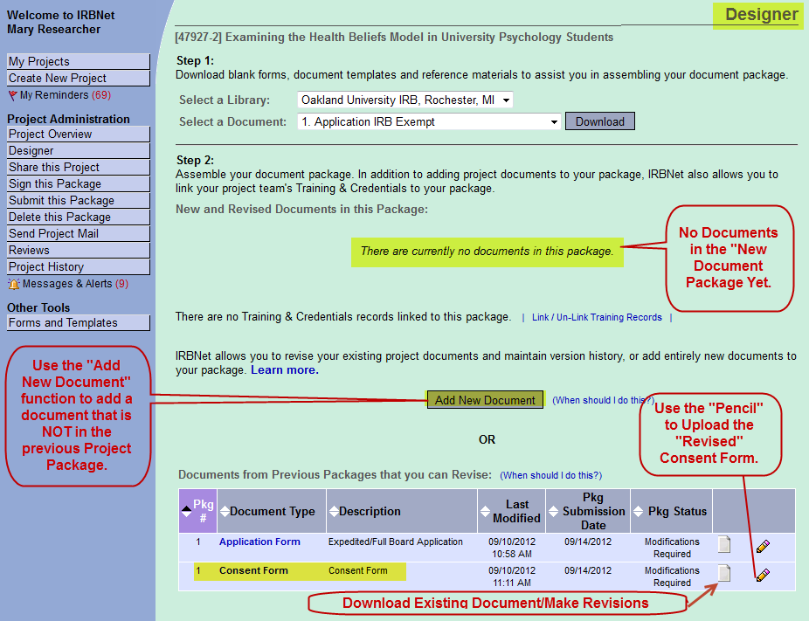

6. In this example, Mary Researcher has received notice that she must modify her Consent Form by clarifying the study’s exclusion criteria. She would update the document from the "New Document Package" she created. This process allows IRBNet and the researcher to track all changes to the project.

7. Because Mary Researcher is making revisions to an existing document that she previously submitted in her first package (see the screenshot of the “Designer” page above), Mary should select options under “Documents from Previous Packages that you can revise”. This section of the “Designer” page allows researchers to revise previously submitted documents.
8. Mary can access the Consent Form she needs to revise by either clicking on the “Paper Icon” next to the Consent Form under Document Type and downloading it to her desktop, or accessing the document from her personal project files.

9. Once all the changes to the consent form have been made, the consent should be updated with the most current version date and saved to your personal project files.
10. To add the revised consent to the new Package, click on the "Pencil Icon" .

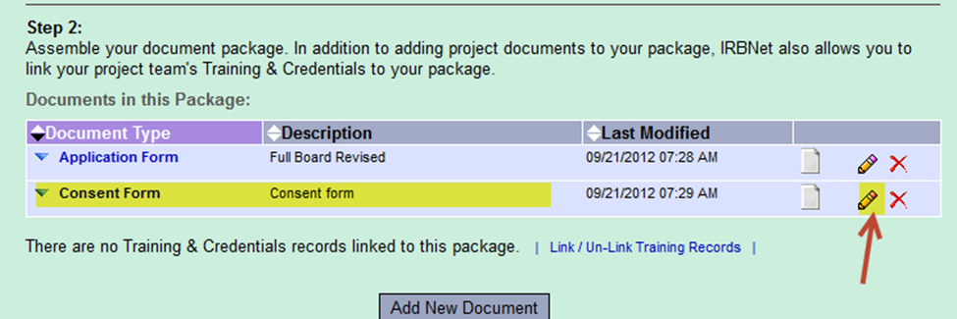

11. At the top of the "Attach Document" page, it will show you that you are "updating" an attachment and it will show you when the original form you are editing was loaded.

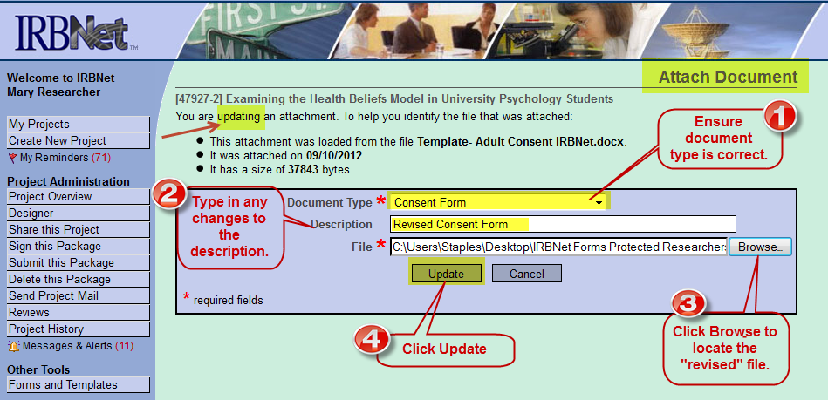

12. Ensure that the "Document Type" drop-down box contains the correct information.

13. Type in any changes to the file "Description" in the Description Text Box.

14. Click the "Browse" button to locate your revised version of your document.

15. Click the "Update" button to finish uploading the revised version. You will then be taken back to the "Designer" screen.
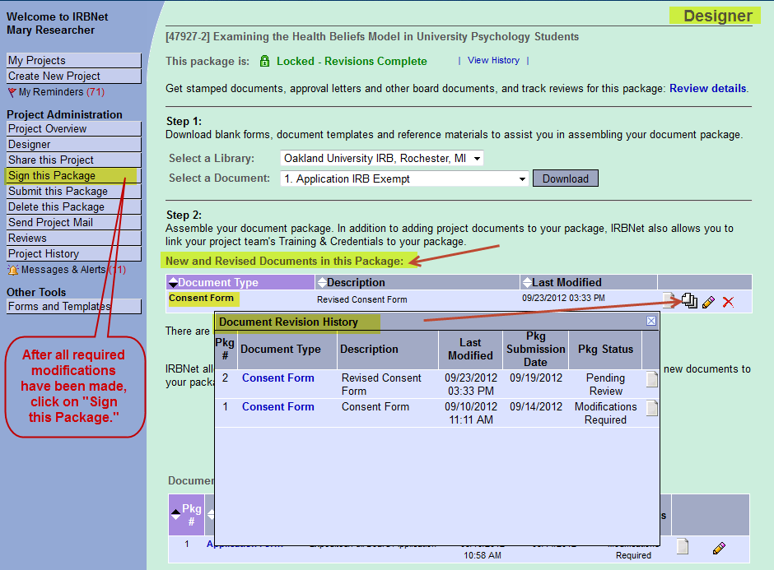

16. Looking at the example above, you can see that the "Revised Consent Form" document is now located under the "New and Revised Documents" heading along with the original "Consent Form" which can no longer be accessed and revised from the first Project Package.
17. Click on the paper stack icon to view all versions of the Consent Form.

18. In addition to uploading new and revised documents, you must also upload a written response to each of the IRB reviewer’s requested modifications.

19. After all required modifications have been made and any required new documents have been attached, click on "Sign this Package." Use the drop-down box to select your role in the Project and then click the "Sign" button. In this example, Mary Researcher is signing the project package as the PI.

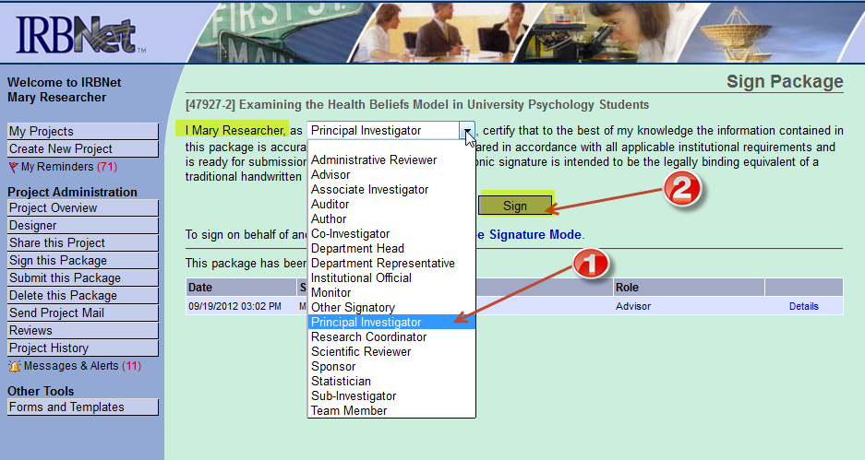

20. On the "Submit Package" page, ensure that Oakland University is selected and click on "Continue."
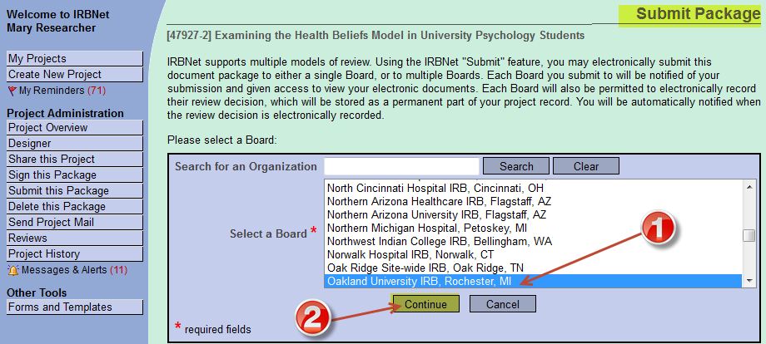

21. After clicking “Continue,” you will be taken to the following screen.
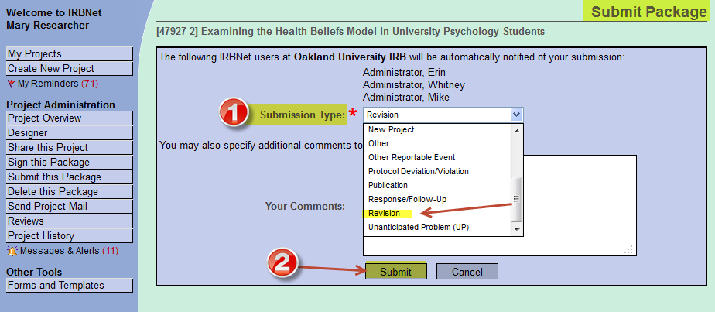

22. Click on the drop-down menu next to “Submission Type.” Select the appropriate option. In this case the PI is submitting a new Project Package created to make changes and/or revisions required by the IRB to gain "Initial" approval. Therefore, the PI would select "Revision" as the Submission Type in this case. (Note that upon submission, the IRB Administrator will change this back to New Project)

23. Click the "Submit" button, and you are done with submitting your new Project Package.

24. If the IRB Board approves your Project, you will receive an e-mail and a decision letter notifying you that the research Project has been approved. It is also possible you may be informed that your study needs further revisions, or that the research was not approved by the IRB.
25. In order to view your notification letter, log in to IRBNet and open your Project. Click on the “Reviews” tab on the “Project Overview” page which will display a list of published board documents including approval and modifications letters.

26. If you have any questions regarding notifications or decision letters you receive from IRBNet, please contact the IRB administrator referenced in the notification message or decision letter (see a samples below).

Approval E-Mail Example
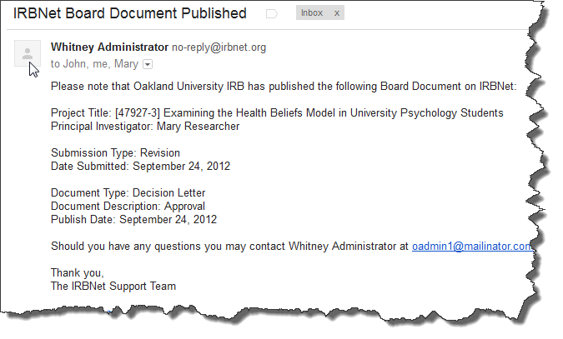

Approval Decision Letter Example

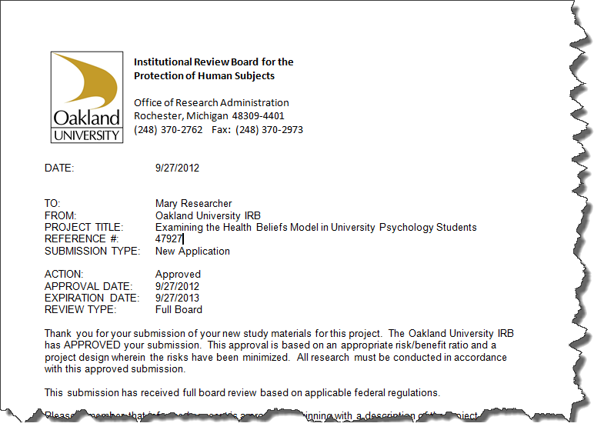

VIII. Submitting New Packages: Amendments, Continuing Reviews, Adverse Event Reports, etc.

For previously approved studies, a Protocol/Research Amendment form is used to request any changes to the Project. When completing the Amendment form, only the sections relevant to the changes to be made need to be completed. The form must be signed by the PI. If the PI is a student, Faculty Advisor must sign the form as well.

For previously approved studies where the researcher would like to extend the approval period, a "Continuing Review Application” must be submitted.
If participant recruitment and research procedures are on-going, copies of the approved, date-stamped consent/assent/parental permission documents, data collection tool(s) and research advertisement if applicable must be re-attached to the Continuing Review Package. If research activities have been completed and the project remains active only for data analysis, only the continuing review application is need.

To report any adverse event including a subject complaint and noncompliance, an Event Reporting Form must be used. The form must be signed by the PI. If the PI is a student, Faculty Advisor must sign the form as well.

The submission process is nearly identical for all Project Packages, with the exception of determining the "Submission Type." Each of these submissions would be submitted to the IRB as a new Package under an existing Project. All required applications and forms can be found in the Forms and Templates library of IRBNet.

It should be noted that forms are updated periodically, therefore, the most recent version of the forms must be downloaded from the Forms and Templates library of IRBNet and used in the submission.

