LOWRY CENTER FOR EARLY CHILDHOOD EDUCATION
FAMILY HANDBOOK & POLICY MANUAL
2017-2018

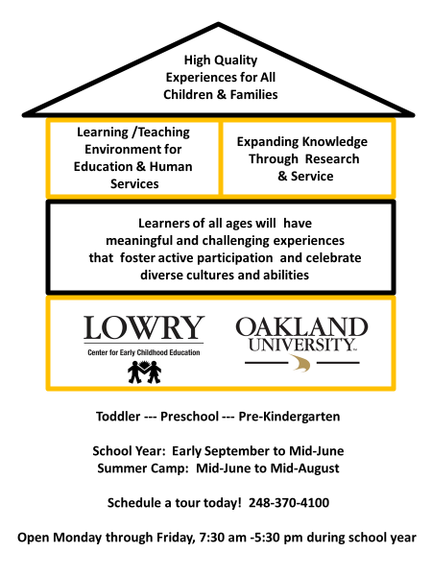
Table of Contents

TOPIC | PAGE #
Welcome, Introduction, Vision, Mission | 2
Components of the Lowry Center for Early Childhood Education | 3
Lowry’s Educational Program | 4
HighScope® Curriculum | 5
Key Development Indicators | 7
Project Approach | 9
Additional Assessment | 10
Inclusion of Children with Special Needs | 11
Child Guidance | 11
Family-Lowry Interactions | 14
Directory of Contact Information | 15
Recruitment, Enrollment, Tuition and Withdrawal Policies | 16
Schedule Changes | 17
Withdrawal and Termination | 17
Enrollment forms | 18
Groups and tuition | 20
Sign-in and Sign-out | 23
Release from Program | 24
Parking | 24
Day to Day Routines and Procedures | 25
Consistency | 26
Separation Anxiety | 26
Supervision of children | 26
Child Abuse and Neglect | 27
Snacks and Meals | 27
Napping and resting | 29
Field Trips | 30
Medical Policies and Procedures | 31
Protection from Hazards | 33
Sanitary Practices | 34
Emergency Situations | 36
Summer Camp | 37

WELCOME!

Family members are always welcome to visit Lowry Center at any time, and we encourage your participation, observation, comments, questions and suggestions. Please read this handbook/policy manual thoroughly so that you are familiar with Lowry practices, procedures and policies. Be sure to ask questions if there are any details you do not understand or topics on which you would like further information.

INTRODUCTION

This handbook and policy manual contains information about our program.

Licensed by the State of Michigan
Lowry policies and procedures are in compliance with the state licensing standards. Since May 28, 2010, licensed centers are required to maintain a licensing notebook which contains information about licensing inspection reports, special investigations, and corrective actions. This licensing notebook is available at the front office for review during regular business hours. Parents must also sign a statement that they are aware of the availability of the licensing notebook (included on the policy form). For more information about Michigan Licensing, visit the website at www.michigan.gov.

Accredited by the National Association for the Education of Young Children (NAEYC)
NAEYC accredited centers adhere to standards and practices that exceed licensing standards. NAEYC standards reflect best practices in early childhood education programs that are supported by research and ongoing evaluation of programs. For more information about NAEYC Accreditation, visit the NAEYC website at www.nayec.org.

This Lowry family handbook and policy manual contains additional policies, procedures, and guidelines that the Lowry Center for Early Childhood Education staff follow in handling both regular program practices and emergency situations. These policies refer specifically to the operations and activities of the Lowry Center. Other personnel and policy issues that affect staff as employees of Oakland University as a whole are covered in the Oakland University Administrative Policies and Procedures.

Lowry Center for Early Childhood Education does not discriminate against race, color, national origin, gender, religion, age, disability, political beliefs, sexual orientation, or marital/family status. Oakland University is an equal opportunity provider and employer.

Vision
Learners of all ages will have meaningful and challenging experiences
that foster active participation and celebrate diverse cultures and abilities.

The Lowry Center for Early Childhood Education strives to be an exemplary educational program for young children where Lowry staff, Oakland university faculty, staff, and students collaborate with children and families on a regular basis in order to achieve excellence in the field of Early Childhood Education.

Mission
The mission of the Lowry Center for Early Childhood Education is to provide an exemplary educational and laboratory setting which focuses on three related components and purposes:

- Provide high quality experiences for all children and families
- Provide a learning lab/teaching environment for Education, Human Services, and related fields
- Expand knowledge through research and service

These components are described in the sections that follow.

What is a High Quality Program for Children and Families?
The Early Childhood field has established professional standards based on knowledge of child development that guide teachers in their practice. The National Association for the Education of Young Children (NAEYC) has published a position statement outlining the principles and guidelines of these professional standards. Key elements of Developmentally Appropriate Practice are outlined below. Additional information is available at www.naeyc.org or at Lowry.
☺ A Holistic or Whole Child approach to learning and growing
Attention is given to all areas of children’s development - physical, intellectual, social and emotional growth, and learning.
☺ Learning Through Play and Exploration
There is a large body of research that indicates that children learn best through play and exploration. Overly structured environments not only do not provide children with opportunities to learn, but have also been shown to dampen children’s enthusiasm for learning and cause undue stress.
☺ Appropriate Expectations
Children are provided with challenging and exciting opportunities to learn and grow, but not pushed to perform beyond their abilities or to meet a set of standards based on “speeding up” learning or “hurrying” skill acquisition.
☺ Fostering Independence and Choice
Lifelong learning skills begin in the early childhood years. Children should have many opportunities to make choices about what activities they will do, how they will accomplish the goals they set, and even about how they will handle their emotions and social interactions. At the same time, children need consistent, reasonable expectations for their behaviors and actions that ensure that everyone in the classroom is safe, secure, and comfortable.
☺ Involvement of Family and Community
Family members are children’s first and most important teachers. In developmentally appropriate programs, teachers, and family members are partners in providing the best experiences for children. It is also important to draw on the experiences of the families and the characteristics of the community in order to provide culturally relevant experiences for all children in the program.

What is a Learning Lab?
Many two- and four-year colleges and universities with education and human service programs provide settings where college students learn about and practice teaching, curriculum development, and program management, or gain experience observing children so that they are better prepared for their future professions in related fields such as counseling, nursing, physical therapy, etc.

Often college programs arrange for a combination of “field” experiences in community early childhood
settings, and “lab” experiences in facilities on or near campus and supervised by college faculty. The Lowry Center for Early Childhood Education is a “lab” setting where college students can gain the kind of “guided apprenticeship” under the supervision of faculty and mentor teachers that is necessary in learning to take active roles in their future professions.

How do we expand knowledge through research and service?
Research
The Lowry Center for Early Childhood Education is a setting where faculty and students from Oakland University can conduct research studies about children’s learning and development, about teacher education practices, and about early childhood program policies and practices. All research studies proposed at Lowry are evaluated by a research committee composed of OU faculty and Lowry staff to ensure that the studies employ appropriate methods, that the Lowry program is not overly disrupted by the implementation of the research, that the risks for participants is low, and that confidentiality of participants is maintained. Once a proposed study is evaluated to be appropriate for the Lowry setting, researchers must complete an application to the Institutional Review Board (IRB) to further ensure the procedures protect the rights of Human Subjects in research.

Service
Lowry is also a setting where faculty and students from other educational institutions come to observe and consult with Lowry staff and OU faculty. In addition, Lowry staff often participate as presenters in OU classes and in local, state, and national conferences, sharing information about Lowry educational practices such as curriculum, child assessment, and program management. Lowry also collaborates with community agencies and groups to provide community-based activities on site or in the surrounding community such as education fairs, community forums, educational presentations, family workshops, and other events.

LOWRY’S EDUCATIONAL PROGRAM

Young children thrive in educational settings that are child-centered and provide a stimulating learning environment with warm, nurturing, and well-trained teachers. Children grow and develop to their fullest capacity if given many opportunities to explore, create, and problem solve. Children learn best when they are engaged in active learning experiences that are appropriate to their developmental level, hands-on, relevant to their daily lives, and come directly from their backgrounds, interests, and talents. They develop emotionally and socially when provided with many opportunities to have quality adult and child interactions in both small and large group settings. All experiences planned for children focus on their needs and interests and incorporate educational objectives in a meaningful way. Children are encouraged to initiate many of their own activities, learn to solve problems independently, and to make many choices on a daily basis. Being encouraged and empowered to make choices such as who to play with, what materials to use, and what experiences they might engage in, helps them to feel a central part of the teaching and learning process. This promotes a stronger sense of self and a higher level of intrinsic motivation. Cooperation and compromise become components of social learning as the children experience and learn ways to interact in a group setting. Lowry teachers are able to gear activities and interactions for individual children within the group setting. Activities and lessons are open-ended and child-centered, making it possible for all children to participate at their own level and in their own way.

Lowry Staff
The Lowry teachers in each classroom are highly qualified professionals who have specialized training and degrees in early childhood education. Most of the Lowry teaching staff have or are currently working on a Master’s degree in Early Childhood Education. The teachers have several roles at the Lowry Center. First, the teachers work in teams to design and implement a developmentally appropriate curriculum for your children. The Lowry teachers also supervise and mentor student staff, student teachers, volunteers, and others who observe or do research at Lowry. Lowry teachers represent Lowry in the community by teaching courses at OU or local colleges, presenting at conferences and workshops, and hosting visiting teachers. Finally, Lowry teachers facilitate or participate in research projects that OU faculty and students conduct at Lowry.

Student staff are Oakland University undergraduate students in a paid teaching assistant positions. Many of our student staff are completing studies in the fields of education, psychology, social work, nursing, and other fields focused on children and families.

HighScope® Curriculum
Lowry Center for Early Childhood Education uses the HighScope® Early Childhood Curriculum. The curriculum was developed by the HighScope® Educational Research Foundation located in Ypsilanti, MI. The HighScope® curriculum is one of the most researched and evaluated early childhood curriculums in the nation. It is used extensively in the U.S., and in several countries worldwide.

The HighScope® Preschool “Wheel of Learning”

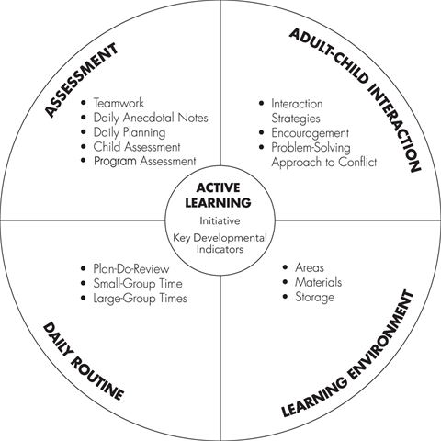

The HighScope® “Wheel of Learning” diagram above highlights the key features of the curriculum.

The environment, schedule, activities, and adult-child interactions are designed to foster children’s development in the following areas:
Physical: Learning how one’s body works in relationship to self, to space, and in relationship with objects and people. This includes large motor skills and experiences such as running, climbing, hopping, and moving to music; small motor skills and experiences such as placing puzzle pieces, grasping, cutting, and stringing beads.
Social/Emotional: Learning to separate from the family; developing independence; managing emotions; interacting with peers and adults; solving social conflicts such as sharing, and learning to play cooperatively.
Cognitive: Learning to problem solve; make decisions; conceptually understand and organize things, ideas, and relationships in the environment.
Language: Communicating with peers and adults; naming and describing objects and events in the environment; expressing feelings and ideas.

Learning Environment
The classroom environment supports children’s development by having age- and developmentally-appropriate materials, and child-size furniture and equipment. The classroom space is divided into well-defined interest areas to encourage distinctive types of play and promote development in all areas. These areas are flexible to accommodate practical considerations and children’s changing interests. Materials in each room are labeled with pictures, drawings, outlines, and words that encourage children to categorize materials. The labels also encourage children to be independent and take ownership of their classroom environment.

Daily Routine
A consistent daily routine supports active learning and builds on children’s interests. Through active learning children construct knowledge through immediate hands-on experiences that are supported by adults. The HighScope® daily routine includes the Plan-Do-Review process, which enables children to express their intentions, carry them out, and reflect on what they have done. Planning time (“Plan”) in the HighScope® approach is a process in which internal goals shape anticipated actions. As young children plan, they may start with a personal intention. These intentions may be expressed through actions, gestures, or words. After planning children carry out their plans during work time. Work time (“Do”) provides an opportunity for children to carry out self-initiated plans through a variety of different types of play. Work time promotes children’s innate desire and need to explore, experiment, invent, construct, and pretend. Play is the work of the child. Recall time (“Review”) helps children make sense of their actions during work time. During
recall children remember and reflect upon their experiences by talking with both children and adults. Also included in the daily routine are a small group time, large group time, and an outside time. During small group time children are encouraged to explore and experiment with new or familiar materials adults have selected based on their daily observations of children’s interests, curriculum goals, and the key experiences. During large group time both children and adults initiate music and movement activities, sharing, discussion, classroom communication, and stories. During outside time children engage in a variety of large motor activities, and continue to explore concepts.

Sample Half-Day Routine | Sample Full-Day Routine
9:00-9:20 Greeting/table activities/reading  9:20-9:30 Clean Up  9:30-9:45 Large Group Circle time – attendance, weather, greeting friends, etc.  9:45 -10:00 Small Group Activity- teacher planned activity focusing on Key Developmental Indicators  10:00-10:30 Large Motor (Outside or Atrium)  10:30-10:45 Snack/Planning Time  10:45-11:35 Work Time (Child Initiated – choice of areas)  11:35-11:45 Clean Up  11:45-12:00 Large Group Circle Time (Music/Literacy/Recall Time) | 9:00-9:20 Greeting/table activities/reading  9:20-9:30 Clean Up  9:30-9:45 Large Group Circle time – attendance, weather, greeting friends, etc.  9:45 -10:00 Small Group Activity- teacher planned activity focusing on Key Developmental Indicators  10:00-10:30 Large Motor (Outside or Atrium)  10:30-10:45 Snack/Planning Time  10:45-11:35 Work Time (Child Initiated – choice of areas)  11:35-11:45 Clean Up  11:45-12:00 Large Group Circle Time (Music/Literacy/Recall Time)  12:00-12:30 Lunch (Diapers, rest room)  12:30-1:30 Nap/Rest time (Books, Quiet Music)  1:30-2:30 Table choices  2:30-2:40 Clean Up  2:40-3:00 Wash hands, snack  3:00-3:15 Large Group Circle Time (Music/Literacy)  3:15-3:25 Recall Time  3:25-3:35 Clean Up  3:35-4:00 Large Motor (Outside or Atrium)

Adult-Child and Child-Child Interactions
Adults using the HighScope® preschool approach use adult-child interaction strategies as they converse and play with children throughout the day. Adults practice positive interaction strategies (sharing control) with children where they focus on children’s strengths and form authentic relationships with children. Teaching staff strive to support children’s play and adopt a problem solving approach to social conflict. The HighScope® curriculum supports observing children and authentic assessment. Through observation and interaction, adults get to know children. They watch and listen closely to children as they work and play with them to find out what interests them, what holds their attention, and what they understand about their world. This information serves as a basis for assessment and planning for classroom strategies and activities.

Assessment of Children’s Learning
HighScope® Key Developmental Indicators (KDI’s) are concepts and relationships that children are striving to understand. The KDI’s are listed below. KDI’s are used both to plan activities for children that are developmentally appropriate and also as a framework for observing and assessing children throughout the school year. Lowry staff take anecdotal notes on individual children each day. These notes are entered into a software program called the Child Observation Record (COR) which provides a summary of development and growth across various domains. During two (2) family conferences in the fall and spring, parents are provided with the parent report based on the COR assessment. Lowry teachers also prepare a portfolio for each child, including photographs and anecdotal records and samples of children’s work and activities.

HighScope® Preschool Curriculum Content — Key Developmental Indicators
A. Approaches to Learning
- Initiative: Children demonstrate initiative as they explore their world.
- Planning: Children make plans and follow through on their intentions.
- Engagement: Children focus on activities that interest them.
- Problem solving: Children solve problems encountered in play.
- Use of resources: Children gather information and formulate ideas about their world.
- Reflection: Children reflect on their experiences.
B. Social and Emotional Development
- Self-identity: Children have a positive self-identity.
- Sense of competence: Children feel they are competent.
- Emotions: Children recognize, label, and regulate their feelings.
- Empathy: Children demonstrate empathy toward others.
- Community: Children participate in the community of the classroom.
- Building relationships: Children build relationships with other children and adults.
- Cooperative play: Children engage in cooperative play.
- Moral development: Children develop an internal sense of right and wrong.
- Conflict resolution: Children resolve social conflicts.

C. Physical Development and Health
- Gross-motor skills: Children demonstrate strength, flexibility, balance, and timing in using their large muscles.
- Fine-motor skills: Children demonstrate dexterity and hand-eye coordination in using their small muscles.
- Body awareness: Children know about their bodies and how to navigate them in space.
- Personal care: Children carry out personal care routines on their own.
- Healthy behavior: Children engage in healthy practices.
D. Language, Literacy, and Communication¹
- Comprehension: Children understand language.
- Speaking: Children express themselves using language.
- Vocabulary: Children understand and use a variety of words and phrases.
- Phonological awareness: Children identify distinct sounds in spoken language.
- Alphabetic knowledge: Children identify letter names and their sounds.
- Reading: Children read for pleasure and information.
- Concepts about print: Children demonstrate knowledge about environmental print.
- Book knowledge: Children demonstrate knowledge about books.
- Writing: Children write for many different purposes.
- English language learning: (If applicable) Children use English and their home language(s) (including sign language).
E. Mathematics
- Number words and symbols: Children recognize and use number words and symbols.
- Counting: Children count things.
- Part-whole relationships: Children combine and separate quantities of objects.
- Shapes: Children identify, name, and describe shapes.
- Spatial awareness: Children recognize spatial relationships among people and objects.
- Measuring: Children measure to describe, compare, and order things.
- Unit: Children understand and use the concept of unit.
- Patterns: Children identify, describe, copy, complete, and create patterns.
- Data analysis: Children use information about quantity to draw conclusions, make decisions, and solve problems.
F. Creative Arts
- Art: Children express and represent what they observe, think, imagine, and feel through two- and three-dimensional art.
- Music: Children express and represent what they observe, think, imagine, and feel through music.
- Movement: Children express and represent what they observe, think, imagine, and feel through movement.
- Pretend play: Children express and represent what they observe, think, imagine, and feel through pretend play.
- Appreciating the arts: Children appreciate the creative arts.

G. Science and Technology
- Observing: Children observe the materials and processes in their environment.
- Classifying: Children classify materials, actions, people, and events.
- Experimenting: Children experiment to test their ideas.
- Predicting: Children predict what they expect will happen.
- Drawing conclusions: Children draw conclusions based on their experiences and observations.
- Communicating ideas: Children communicate their ideas about the characteristics of things and how they work.
- Natural and physical world: Children gather knowledge about the natural and physical world.
- Tools and technology: Children explore and use tools and technology.
H. Social Studies
- Diversity: Children understand that people have diverse characteristics, interests, and abilities.
- Community roles: Children recognize that people have different roles and functions in the community.
- Decision making: Children participate in making classroom decisions.
- Geography: Children recognize and interpret features and locations in their environment.
- History: Children understand past, present, and future.
- Ecology: Children understand the importance of taking care of their environment.

The Project Approach is also utilized within the HighScope® curricular framework. This approach provides children with the opportunity to predict, test out, and evaluate their ideas, questions, and interests. Within the Project Approach, learning becomes intrinsically motivating for children as they initiate their own learning and discovery. As children are involved in more project experiences, they become familiar and competent in the process and framework of planning, exploring and further developing, and concluding a piece of work that is something interesting and worthwhile for them. Their hands-on involvement in the process allows them to relate new skills and concepts to past experiences and to synthesize new and old experiences.

The five major aims of the Project Approach are:
- Intellectual goals and the life of the mind
- Balance of activities
- Fieldwork/Work Time/Implementation
- Review/Recall
- Display/Share

For further information on the Project Approach see:
Engaging Children’s Minds: The Project Approach, by Lillian Katz & Sylvia Chard.
The Project Approach (Book Two) by Sylvia Chard, PhD.
Young Investigators: The Project Approach in the Early Years, by Judy Harris Helm & Lillian Katz.

Both the HighScope® approach and the Project Approach utilize documentation of children’s activities. Throughout the year, you will notice many photographs and brief descriptions outside of each classroom of activities and projects that children and teachers have been involved in. The purpose of this documentation is threefold:

- First, it allows family members and visitors to know and understand what kinds of events, activities and learning are taking place on a regular basis. This display of children’s intellectual, physical, and social work honors their role in their own learning.
- Second, it allows family members to probe more deeply with their own child what has been going on at school. If you ask, “What did you do at school today?” and the answer is “I played.” – that is true! However, you can use the documentation to encourage your child’s language and engagement with you. Say, “Tell me about what you are doing in that picture!”
- Third, this same documentation is often used in children’s portfolios and as a basis for the Child Observation Record Assessment tool.

The Difference Between Preschool and Pre-kindergarten Programs
- There are very few programmatic differences between these two programs.
- The approach described in this handbook is the same for each of these programs.
- The curriculum areas and Key Developmental Indicators are also the same.
- Although the approach and KDI’s are the same structurally, you may see a difference in what the
children naturally do at 4 and 5 years of age, as opposed to 3 and 4 years of age. Interests change and develop. Developmental levels are often higher.
- Language and literacy are promoted in much the same way in both programs; however, you may see
more reading and writing in a pre-kindergarten program simply because of the more advanced age of
the children in the program.

Additional Assessment
In addition to the ongoing assessment embedded in daily anecdotal records and the COR, each family is asked to complete a standardized developmental screening assessment called the Ages and Stages Questionnaire (ASQ®). Professionals rely on ASQ® for the best developmental and social-emotional screening for children from one month to 5 ½ years. Highly reliable and valid, ASQ® looks at strengths and trouble spots, educates parents about developmental milestones, and incorporates parents’ expert knowledge about their children.

As a partner site for the Oakland County Great Start ASQ® project, the Lowry Center is able to offer the ASQ® online, via a secure link on the Lowry website. Once a parent completes the ASQ® for their child, only Lowry staff (i.e., Faculty Director and support staff managing the data along with your child’s teacher) have access to the results. Using the online system, we are able to generate a summary of the ASQ® scores in all domains including communication, gross motor, fine motor, problem-solving, and personal-social skills, along with activities that promote learning at each child's developmental stage in all major domains.

Lowry teachers may also complete an ASQ® based on their observations and interactions with children in the classroom setting. The ASQ® is a tool to facilitate conversations between parents and teachers, and to encourage home-school collaboration. If a child's scores on the ASQ® screening assessment are in the low-to-middle range of development, Lowry teachers will discuss possible courses of action which include continued observation and re-assessment at a later time or referral to Early On (for ages birth to 3) or the Child Find office in the child's school district (ages 3 to 5). If a parent or teacher has concerns about a child's social or emotional development, family members or teaching teams may also complete an Ages and Stages Questionnaire-Social Emotional® (ASQ-SE®). The ASQ-SE® is only completed after the ASQ® since social and emotional development are often related to physical, cognitive, and language domains of development.

The Ages and Stages Questionnaire® is published by Brookes Publishing and is a reliable and valid screening instrument. The validity of Ages & Stages Questionnaires® Third Edition has been studied extensively. Psychometric studies based on normative samples of more than 18,000 questionnaires show high reliability, internal consistency, sensitivity, and specificity.

Inclusion of Children with Special Needs
The Lowry Center is designed to be an inclusive setting for typically developing children, as well as children who have special needs. Lowry Center supports each child’s growth based on their individual development in order to maximize success for all children. Some children enroll in Lowry Center with identified special needs. Lowry Center teachers want to become a member of the collaborative team that supports those children. Teachers are able to attend Individual Family Service Plan (IFSP) meetings and Individual Education Plan (IEP) meetings when invited by parents or other service providers. Lowry teachers can support intervention plans and activities by embedding goals and objectives into daily classroom activities.

In the event that either a parent or a teacher begins to notice any type of developmental concern after a child has been attending Lowry Center, teachers will work with parents to identify the best possible ways to support that child. Family members may be asked to complete another ASQ® for the age range of the child, and if needed, resource information can be provided on how to obtain additional assessment. Classroom goals and strategies can be developed to address individual children's needs. Should additional services be needed, Lowry Center teachers will collaborate with parents and other professionals to make sure that everything is being done to provide maximum opportunities for educational and developmental success.

CHILD GUIDANCE

Respectful and trusting relationships between adults and children are the cornerstone of the Lowry Center’s Child Guidance policies. Positive, guiding communication is our primary method of helping children to develop a sense of independence, confidence, and competence in their own abilities and to get along with peers and adults during classroom activities. Daily schedules, curriculum concepts and components, classroom arrangements, teachers, and student staff are chosen to promote positive and pro-social learning experiences.

Children are afforded the following rights in our program:
- The right to be an individual with special talents and needs
- The right to be protected from physical and emotional harm
- The right to need special help in some areas
- The right to be respected by all individuals in the program

We regularly use the HighScope Steps to Problem Solving and Conflict Mediation with Young Children:
  - Approach calmly, stopping any hurtful actions
  - Acknowledge children’s feelings
  - Gather information from children
  - Restate the problem(s)
  - Ask for ideas for solutions from the children involved and choose one together
  - Be prepared to give follow-up support

Becoming socially and emotionally competent is a DEVELOPMENTAL process with many components:
- Young children are in the process of learning to use words and other forms of communication to express their feelings and needs. (Language delays and learning multiple languages can make this more challenging for some children).
- Young children learn from experiences to connect actions to consequences.
- Young children learn over time to control impulses.
- Young children need practice to cooperate, share and take turns with others.
- Young children gradually learn to take into account other’s feelings and perspectives.
- Young children gradually learn to distinguish what is real and what is fantasy.

Challenging Behavior refers to any activity that:
- Interferes with children’s learning, development and success at play
- Is harmful to the child, other children or adults
- Puts a child at risk for later social problems or school failure

The causes of challenging behavior are extremely complex and intricately interconnected. We focus on elements in the child’s environment that we can influence directly and work to increase children’s capacity to develop the skills that support them in full participation in the classroom and with adults and peers.

Strategies that have been shown to work effectively are:
- Setting clear and consistent expectations and limits
- Assisting children in social competence and impulse control
- Calmly acknowledging children’s feelings before beginning to deal with conflicts and solutions
- Posing choices that give the child control over the situation
- Modeling the expected behavior—act as we expect children to act
- Telling children what to DO, instead of what not to do
- Observing and analyzing behavior (adult’s and children’s) to better understand it
- Adjusting environments so that challenging behavior is not needed
- Teaching appropriate behavior that helps children participate fully
- Naming the behavior you want to reinforce (“You put the puzzle on the puzzle shelf all by
yourself!”)
- Avoiding comparisons between children
- Helping children appreciate their own behavior and achievements (“You must feel proud of the
way you shared the markers with Sam,” rather than “I like the way you…”)
- Remaining calm and respectful, not angry or threatening
- Viewing challenging behavior as an opportunity to teach
- To encourage sharing, providing sufficient toys, showing our own generosity toward others and
acknowledging children when they do share
- Avoiding situations where children must wait beyond their ability
- Preparing a safe environment
- Trusting children to succeed
- Adequately preparing children for transitions and changes in their lives
- Stating rules simply – “I cannot let you throw the blocks”
- Expressing interest in children’s play or work, commenting on specifics

The following practices are NEVER employed at the Lowry Center:
- spanking or any form of physical punishment
- ignoring the child as a form of withholding comfort, contact, or needed interaction
- threatening
- humiliating or belittling
- yelling
- embarrassing
- insulting
- teasing
- using extrinsic reward strategies
- withholding food or rest
- shaming
- scaring or intimidating
- isolated time-out

Extreme and Repeated Challenging Behaviors
If extreme behaviors that are dangerous occur, the child may be supported by finding an unused space for him/her and the teacher. During that time the teacher will provide a cooling-down time, assist with emotional issues, and when emotional stress has dissipated or lessened, proceed to use the steps to “Problem Solving and Conflict Mediation with Young Children.”

Further steps in dealing with repeated extreme behaviors can include some or all of the following:
- Meetings with Faculty Director, parents, teachers to learn from each other, strategize with each other
and to support each other and the child(ren).
- Observation by and intervention of university and/or special education behavioral experts.
- Referral to community agencies or resources that provide consultative services to families and/or
teachers (e.g., Project STAR).
- Referral to a medical professional trained in child development.
- Referral to a program that more appropriately meets special needs of the individual child. [If the
Lowry setting is deemed unsuitable for supporting the needs of a child with challenging behavior,
every effort will be made to provide resources and referrals for the family].

One or more of the above steps may be taken depending on individual needs and circumstances when behavioral challenges become extreme.

FAMILY-LOWRY INTERACTIONS

We know families are BUSY! We value any level of input and participation that you are comfortable providing!

Informal Exchanges
One way that we share information with family members is during informal exchanges daily as children arrive and depart. We hope you will ask your child’s teachers questions, make suggestions, and share information that helps us learn about your child(ren).

Information Exchange
Lowry teachers will share classroom information in a variety of formats, including displays on the walls outside the classrooms, and sending paper or electronic newsletters. Newsletters, reminders, and notices may be placed in your child’s cubby. Please check your child’s cubby daily!

We also frequently post flyers/announcements on the entry door. There are handouts, brochures, and other kinds of information about OU and community programs at the reception desk and on the table in the front entry hallway, and posted on the Family board near the drinking fountains. If you can’t find something, just ask!

Lowry also has a Family Email List. Emails regarding upcoming events, policy changes, or other important announcements will be made via this email list. Please contact the clerical staff if you have changes to your email contact information.

Family Home Activities
Lowry teachers will sometimes send home ideas for activities to do at home, based on what they have observed your child doing in the classroom, or to extend or enrich a concept that children are exploring at school.

Family Conferences
Family conferences are scheduled twice each school year—in the fall and in the spring. Watch the calendar for announcements about scheduling conferences with your child(ren)’s teachers. You may also request a formal conference any time during the school year to discuss your child’s program.

Family Advisory Committee
The Lowry Family Advisory Committee meets quarterly in September, December, March, and June. If you would like to be involved, contact the Faculty Director or complete the information on the Family Interest section of the enrollment survey.

Family Activities
We plan different types of family involvement activities during the year. Some may be geared towards sharing additional information on a topic of interest; others are social kinds of activities such as potlucks and picnics; others are focused on classroom events and activities.

Family Members as Volunteers
Families can participate in many ways at Lowry – in classroom activities, helping plan or implement special events, helping with fundraisers, donating materials, sharing your special expertise, etc. We appreciate your support!

Grievance Procedures
If a parent/guardian/family member has a grievance, the following steps should be taken:
- Talk over the problem with the lead teachers/primary contact. Please schedule a meeting with the teacher for this purpose. Pick-up and drop-off times are for social interactions and are often hectic.
- If discussion does not resolve the issue, the parent should submit the complaint in writing to the Faculty Director. Depending on the area of complaint, the Faculty Director may share this letter with related parties.
- A meeting with the Faculty Director, parent/guardian, and teaching team will be scheduled.
- The decision of the Faculty Director will stand. For further recourse, discussion and/or clarification, you may contact the University Leadership contingency listed below.

Directory of Contact Information

LOWRY CENTER for EARLY CHILDHOOD EDUCATION  Faculty Director  Dr. Julie Ricks-Doneen  102 Pawley Hall  248 370-4107  ricksdon@oakland.edu | SCHOOL of EDUCATION and HUMAN SERVICES  Dean  Dr. Jon Margerum-Leys  415C Pawley Hall  248 370-3045 – Marian Nowosatko, secretary  jmargerumleys@oakland.edu, nowosatk@oakland.edu
Financial Coordinator  Anita Marshall  106 Pawley Hall  248 370-2647  ajmarsha@oakland.edu | Chair, Human Development and Child Studies  Dr. Ambika Bhargava  405A Pawley Hall  248 370- 3067  abhargav@oakland.edu
Clerical Staff  Kelly Meador  248 370-4100  kameador@oakland.edu | WEB  www.oakland.edu/lowry  www.facebook.com/lowrycenter
AM Toddlers (half-day)  112 Pawley Hall  248 370-4103 | Full-day Toddlers  116 Pawley Hall  248 370-4101
Preschool “A”  120 Pawley Hall  248 370-4105 | Preschool “B”  126 Pawley Hall  248 370-2608
Pre-kindergarten “A”  130 Pawley Hall  248 370-2609 | Pre-kindergarten “B”  J136 Pawley Hall  248 370-2610
Kitchen Phone  248-370-4656 | IF YOU ARE AT AN ENTRANCE TO LOWRY AND NO ONE IS AT THE FRONT DESK, PLEASE CALL EITHER YOUR CHILD’S CLASSROOM OR THE KITCHEN.  THANK YOU!

RECRUITMENT, ENROLLMENT, TUITION AND WITHDRAWAL POLICY INFORMATION

These policies ensure that Lowry Center will be able to meet its budgetary obligations.

Recruitment
Lowry Center administrative staff is responsible for recruiting and enrolling children in the Lowry Center for Early Childhood Education. They advertise and post information about the program in strategic areas of Oakland University, local publications, community venues, and in campus publications and events. Telephone and written inquiries are answered promptly and information and enrollment packets are sent out as requested.

The Lowry Center begins registration for the Fall program in January. Families presently enrolled in a Lowry Program are given the opportunity to register on a first-come, first-served basis, giving first preference for available slots. There is no guarantee of securing a slot if registration is not received prior to the end of the enrollment period.

Lowry Center serves children from 18 months to 5 years of age. Every effort is made to represent diverse families from University students, staff, faculty, and surrounding communities. Within these groups, the school strives to create a diverse culture according to age and gender as well as ethnic, cultural, and socioeconomic background.

Terms of Enrollment
Children of community families enroll for an entire program year (early September through mid-June) OU affiliates (i.e., children of Oakland University students, faculty, and staff) may opt to enroll for the entire program year or register each semester according to their schedule and based on space availability.

Recruitment and enrollment take place whenever there is an opening in the program. The waiting lists are consulted before enrolling. No child slot will be held without pre-payment of the registration fee and deposit.

Enrollment Fees
Our OU Affiliate (i.e., children of OU students, faculty, and staff) Child enrollment fee is $75.00. $25.00 of this fee is a deposit and is refunded in the last month of the semester or the end of the Lowry school year based on the child’s registration schedule. Children who withdrawal prior to the end of the school year will forfeit their deposit. $50.00 of this fee is a non-refundable registration fee.

Our Community Child enrollment fee is $200.00. $150.00 of this fee is a deposit and is refunded in the May payment. Children who withdrawal prior to the end of the school year will forfeit their deposit. $50.00 of this fee is a non-refundable registration fee. No part of the enrollment fee is transferable.

Withdrawal prior to the beginning of the school year
Registration for the upcoming school year begins in January. Families who notify Lowry in writing of their withdrawal by May 31 will receive 100% of their deposit back. The deposit is forfeited if withdrawal occurs after May 31st. The $50.00 registration fee is non-refundable.

Schedule Changes
All schedule changes during the school year must be submitted on a Schedule Change form to the Lowry office.
All families may make ONE schedule change prior to September 30 or the first business day following September 30. All changes to the schedule on or after September 30 will be charged a $25.00 processing fee. Such requests may include adding extended care (before- and after-care), or (in pre-kindergarten only) adding lunch (30 minutes) or extending to an afternoon dismissal. Requests will be addressed on a first-come, first-served basis. If hours are dropped from your schedule, your tuition will be adjusted in the next month. You will be responsible for the scheduled amount until then.

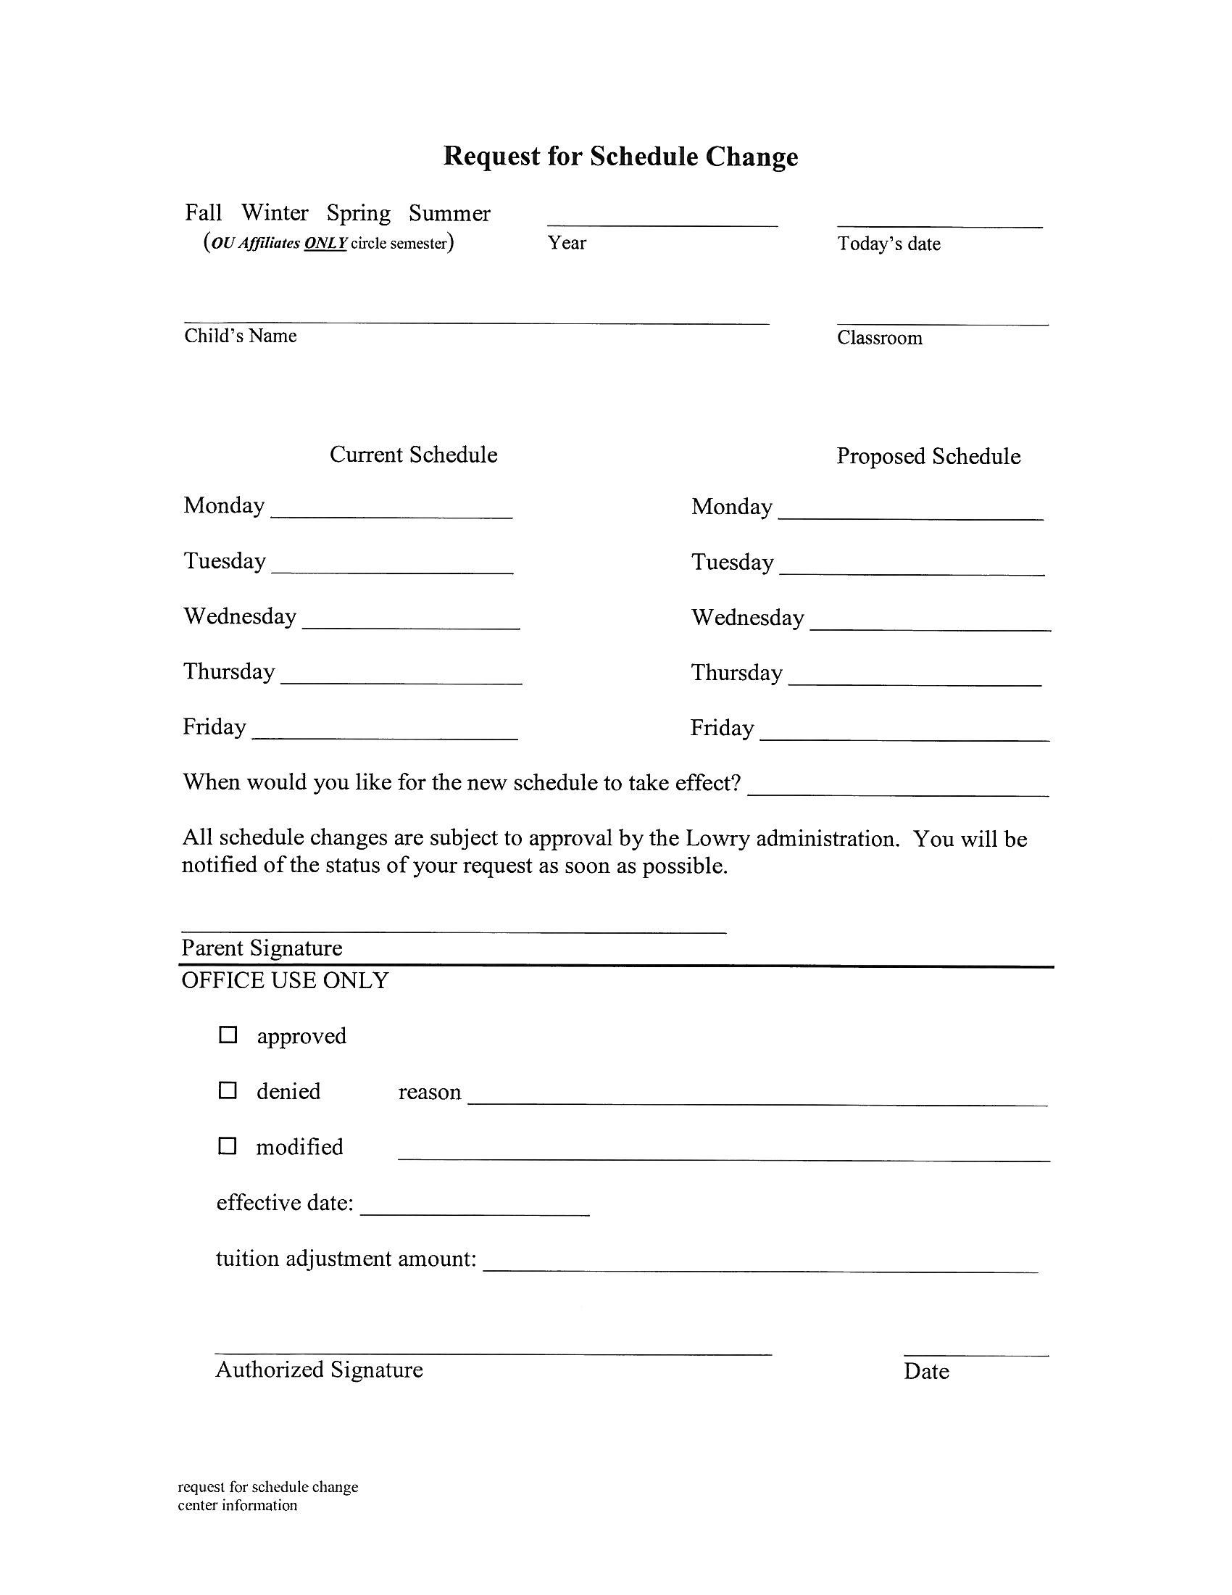
OU Student, staff, and faculty families are asked to submit their new Winter and Summer I semester schedules by the specified date. Semester schedule changes will be granted on a first-come, first-served basis and are subject to space being available.
A blank Schedule Change form

As the semester changes, Oakland University students have first priority for changing their child’s schedule. We will do our best to accommodate class schedules while maintaining an acceptable teacher-to-child ratio and appropriate class size. PRIOR NOTIFICATION OF ALL ADJUSTED SCHEDULES IS EXPECTED.

Withdrawal/Termination of Enrollment
A one-month written notice is required if families withdraw from the program during the school year. Families are responsible for full tuition throughout that month. The initial registration fee and deposit will not be refunded if withdrawal occurs after the start of the program. Families that enroll their child but do not notify Lowry of their decision not to attend Lowry in writing until after the first day of the school year will be held liable for the first month of tuition.

If at any time during the calendar year Lowry staff feels that the Lowry program is not appropriate for or meeting an individual child’s needs, staff will use the following procedures:
- The teaching staff and Faculty Director meet concerning the situation.
- The teaching staff and Faculty Director meet with parents or guardians.
- University or special education support professionals are consulted if necessary.
- If, after meetings and consultation, the decision is reached that the Lowry Center is not appropriate for the child, the child may be withdrawn/terminated from enrollment.
- At the family’s request, staff will assist in finding an appropriate alternative setting for the child.

Waiting List
The main office maintains a waiting list, based on the date the application and fee was received. This allows a family to express interest in the upcoming program year (September through June) and place themselves for possible enrollment. Families looking to enroll for the upcoming school year may submit their waiting list form beginning January 1.

There is a $20.00 non-refundable charge to place your child on the Lowry waiting list (this fee will be charged for each new program year). This list is kept through the end of each program year (June 30).

This list is separated into three groups, with OU affiliates receiving preference in enrollment:
- OU affiliates (children of faculty, staff, and OU students)
- OU and Lowry alumni
- Community members
Siblings of children currently enrolled at Lowry get first preference when enrollment options occur.

Enrollment Forms
The enrollment packet is mostly completed electronically by completing a survey on Qualtrics. Families will be emailed a link to the survey. Please be assured that information collected on the electronic enrollment form is secure. It cannot be accessed without a user name and password. Only Lowry staff will have access to this information. PLEASE NOTE that electronic enrollment forms must be completed and returned no later than your child’s first day of school. You will still need to complete a paper version of the following:

- Two (2) Child Information Records
- Health appraisal/physical Form
- Immunization record (if not completed by the physician on the physical form)
Please note that as of January 1, 2015, licensed centers no longer provide immunization waivers to families. Children who are not current with immunizations should either have a medical waiver (signed by a physician) or a non-medical waiver, obtained from the county health department. Families receive additional information about immunization waivers with their welcome packet.
- Photo/Video/Audio Release
- “Policies Requiring a Parent/Guardian Signature” (2 pages) which include the following sub-sections:
1) Review of Family Handbook
2) Statement of Information about State of Michigan Licensing Notebook
4) Walking Field Trip Permission
5) Permission to post allergy information in classroom(s)
6) Application of Sunscreen
7) Application of Insect Repellent
Office staff is responsible for obtaining the health records required by the Michigan Department of Consumer and Industry Services. Please inform the office staff of any changes in address, phone numbers, or other emergency contact information as they occur.

No child may attend any part of the program without receipt of the above paperwork. This is a licensing regulation and cannot be waived.

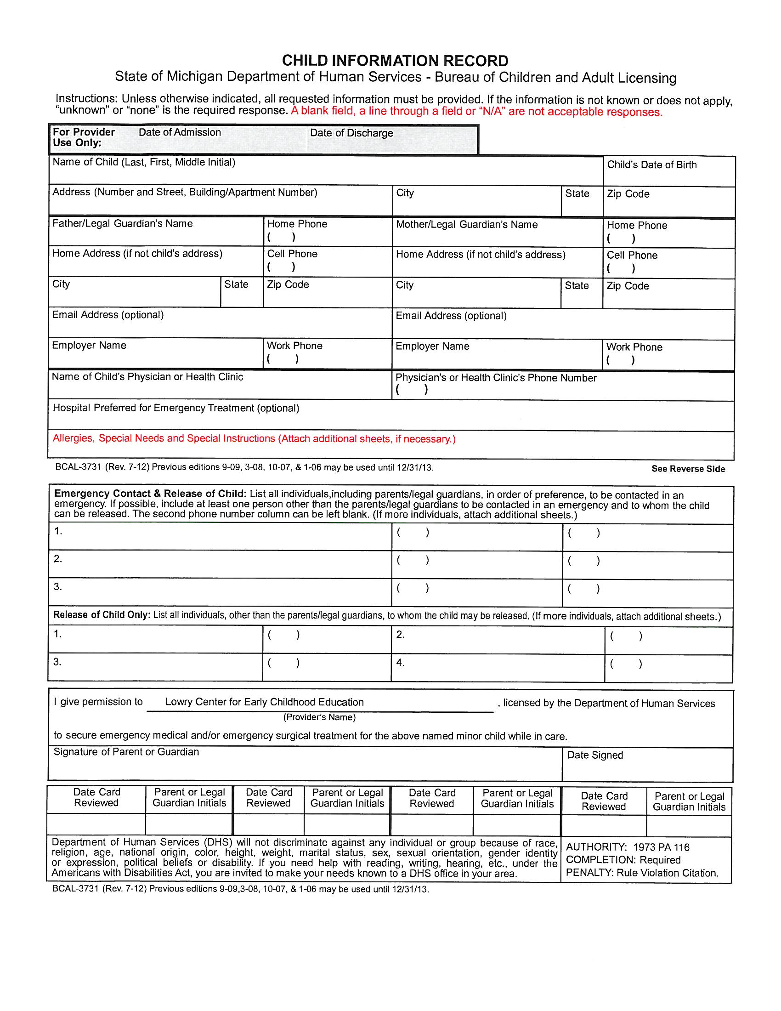

A blank Child Information Record

Confidentiality of Children’s Records
All children’s paper records are kept in secure file cabinets in the offices of the Faculty Director, Financial Coordinator and teaching staff. Electronic records are maintained on secure computers that require specific login access. Records include but are not limited to:
- Enrollment information, including emergency contacts
- Payment information
- Child assessments, education plans, work samples
- Consent forms
- Health information, with the exception of Allergy information (when parental consent is given to post)

PROGRAMS/AGE REQUIREMENTS/CHILD SCHEDULES 2017-2018

Note: Group sizes and ratios meet or exceed State of Michigan Licensing requirements

CLASS OR AGE GROUPING/CAPACITY | AGE REQUIREMENT | ENROLLMENT OPTIONS | TUITION RATES
Toddler Classroom 12 max  1:4 max ratio  9a.m. to 12p.m.  9a.m. to 4p.m. (lunch & nap) | Must be 18 months by the first day of enrollment | - Monday, Wednesday, Friday  - Tuesday, Thursday  - Monday through  Friday | 9a.m.-12p.m. $36.00 per day  9a.m.-4p.m. $60.00 per day
Preschool Classroom 20 max  1:10 max  9a.m. to 12p.m.  9a.m. to 4p.m. (lunch & nap) | 36 months  (3 years) by September 1, 2015 * | - Monday, Wednesday, Friday  - Tuesday, Thursday  - Monday through  Friday | 9a.m.-12p.m. $32.00 per day  9a.m.-4p.m. $52.00 per day
Pre-kindergarten classroom 20 max.  1:11 max ratio  9a.m. to 12p.m.  9a.m. to 4p.m. (lunch & nap) | 48 months  (4 years) by September 1,  2015 * | - Monday, Wednesday, Friday  - Tuesday, Thursday  - Monday through  Friday | 9a.m.-12p.m. $31.00 per day  9a.m.-4p.m. $51.00 per day

*Puts children on track for kindergarten entry dates according to 2012 Michigan Legislation. Individual considerations may be made if all parties (teaching staff, parents, Faculty Director) are in agreement, and if class sizes and adult-child ratios are within State of Michigan Licensing regulations and NAEYC Guidelines.

Before-care and After-care
- Booked in 30 minute intervals only (7:30a.m. to 9:00a.m. and/or 4:00p.m. to 5:30p.m.)
- $3.00 each additional 30 minutes for OU Staff, Student or Faculty
- $5.00 each additional 30 minutes for Community

Annual Registration and Deposit
- Community families: $50.00 registration/$150.00 deposit due upon enrollment.
- OU affiliates: $50.00 registration/$25.00 deposit due upon enrollment. (OU students, staff and faculty members can enroll on a semester to semester basis.)
- If a child withdraws before the end of the school year the deposit is automatically forfeited. A 30-day written notice is required for all withdrawals and the parent is liable for the tuition during those thirty days.
- A 5% tuition discount is given to second sibling. This discount is applied to the lower of the two tuitions.

Tuition Policy
All tuition billing will be as full-day session tuition rates or half-day session tuition rates. The only hourly billing will be for before-care or after-care services.

Tuition invoices for community affiliates will be calculated with a session rate as the base then multiplied by the number of weeks in the school year and then divided into nine (9) equal monthly fees (September thru May). Families will be notified of the number of weeks in their enrollment packet at the beginning of each school year.

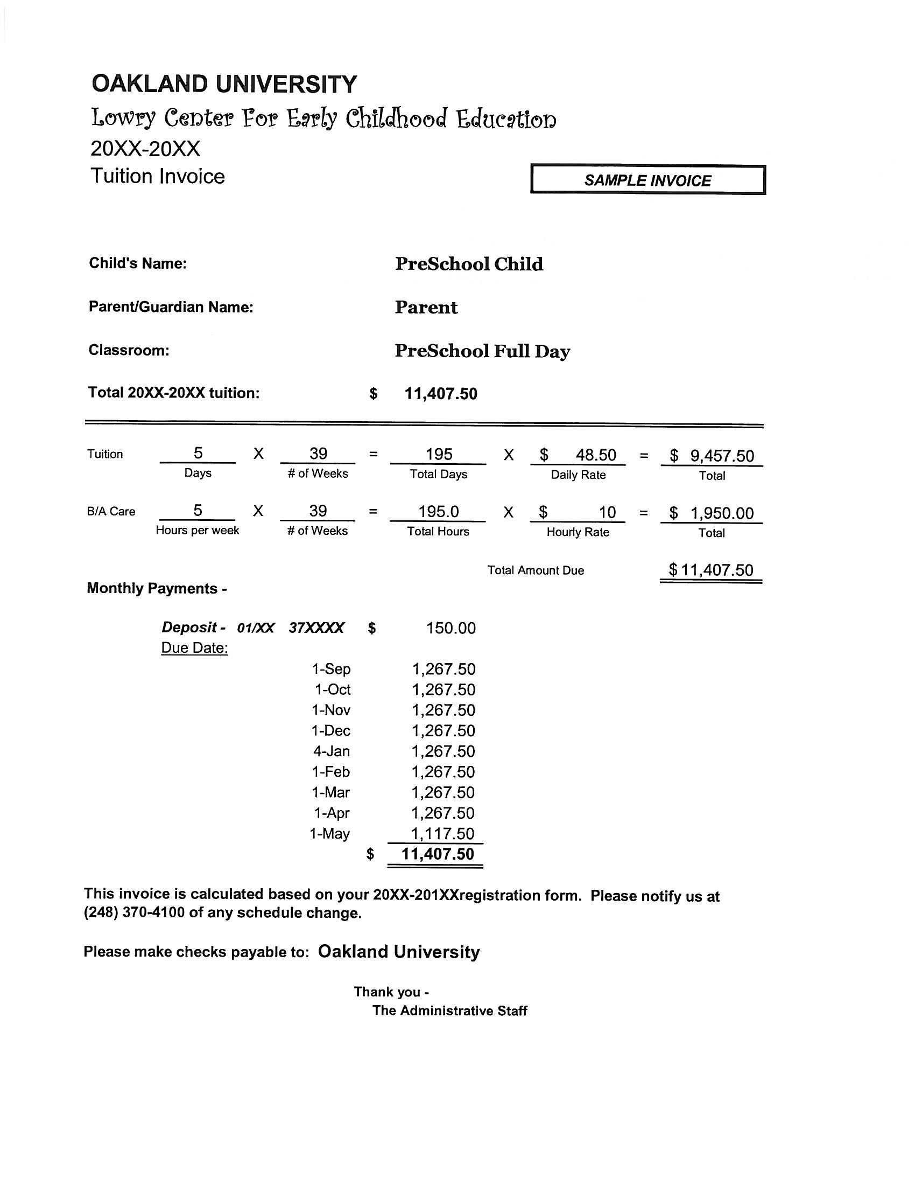

A sample tuition invoice

OU affiliates will be billed by semester depending on the number of weeks in each semester. Tuition invoices will be calculated with a session rate as the base, then multiplied by the amount of weeks in the semester, then divided into equal monthly payments for that semester.

The scheduled days you have chosen for your child’s program may include holidays and other days when Lowry is closed. There is no reimbursement for those days.

Tuition Payments
Tuition is due the first business day of each month or the first day of the month that the child is scheduled to attend Lowry. If Lowry is closed on this day, tuition will be due on the first day Lowry is in operation. Tuition received after the tenth day of each month, or the first business day following the tenth, will be subject to a $25.00 late fee. Tuition payments not made by the last business day of the month will result in the termination of the child’s enrollment contract with Lowry and the forfeit of the deposit. In certain circumstances, alternate payment arrangements can be made with the approval of the Financial Coordinator. Please contact the Financial Coordinator for more information regarding alternate payment arrangements.

Financial Assistance
Families in need of financial assistance are often referred to the Family Independence Agency. The Lowry Center accepts subsidies from this government organization.

There are also a limited number of scholarships available for short-term financial support. Please contact the Faculty Director or Financial Coordinator for additional information.

SCHEDULED PROGRAMS – HOURS AND POLICIES

AM (half-day) sessions: 9:00a.m. to 12:00p.m.
Full-day schedule: 9:00a.m. to 4:00p.m.

All scheduled sessions and extended-care hours must be PAID for even if the child is absent. No refunds or credits will be given except in case of illness/accident requiring a doctor’s care resulting in two or more consecutive weeks of absence. For absence in excess of two consecutive weeks, tuition will be credited for two weeks if the request is made in writing and accompanied by a note from the child’s physician AND the family notifies Lowry prior to the return of their child about the illness. The tuition credit will not exceed two weeks regardless of the length of the child’s absence. Lowry will only grant one two week tuition credit due to illness/accident per school year. Tuition credit cannot be given for family vacations that do not coincide with the Lowry school calendar.

NO TUITION REFUNDS WILL BE GIVEN FOR DAYS THE CENTER IS CLOSED FOR CIRCUMSTANCES BEYOND OUR CONTROL. IF LOWRY WILL BE CLOSED FOR SOME REASON WHEN OAKLAND UNIVERSITY IS OPEN (e.g., WATER MAIN BREAK, POWER FAILURE, etc.), WE WILL MAKE EVERY ATTEMPT TO PHONE FAMILIES BEFORE THEIR CHILD’S SCHEDULED ARRIVAL TIME. HOWEVER, NO TUITION REFUNDS WILL BE GIVEN. IF OAKLAND UNIVERSITY IS CLOSED, LOWRY IS CLOSED.

In the case of inclement weather, please call 248 370-2000 for Oakland University closing information.

Extended-care Hours
Extended-care schedules must be consistent in order to provide appropriate staffing in relation to number of children. Extended-care must be pre-arranged at the time of enrollment. At least 48 hours in advance notice is needed to adjust extended-care schedules. No unscheduled extended-care will be provided without 48 hours advance notice. Rare emergency situations must be cleared with the Faculty Director or Financial Coordinator.
Early Drop-off Policy
If a parent arrives with their child before the beginning of the session, they must remain with that child until the program officially begins. This will insure that Lowry stays in compliance with ratio guidelines from the Licensing Bureau as well as NAEYC accreditation.

Late Pick-up Policy
In the event you anticipate not being able to pick up your child at their scheduled time we ask that you contact the center at 248-370-4100 and notify the Administrative Staff. If a child is picked up later than their scheduled time, the following procedures will be followed:
- First occurrence: Written notification of late pick-up policy and after-care charges applied to the tuition.
- Second occurrence: A $1.00 per minute charge will be added to the bill. Lowry clock time will be used for this calculation. We will start billing after the scheduled pick-up time.

Late Drop-off Policy
AM (half-day) and Full-day sessions begin at 9:00a.m. Children should arrive no later than 9:30a.m. Lowry teaching staff set aside this time each day for welcoming children and easing their transition into classroom activities. It is difficult for staff to leave scheduled classroom activities in order to greet children and ease separation issues after this time. Late drop-off is very disruptive to the child, the class, and often has adverse effects on program quality for all involved. In the event your child needs to arrive later than 9:30a.m., (unavoidable situations, appointments, etc.) we ask that you call ahead of time.

Additionally, after 10:30a.m., staffing will be assessed. If the center is overstaffed at that time, classroom assistants will be sent home, reassigned or rescheduled. Staff ratios must be adhered to. However, to be fiscally responsible, we must assess staffing and regulate costs daily. Therefore, after 10:30a.m., staffing will be based on the children who are physically present at that time. Children who arrive after 10:30a.m. without prior notification may not be accepted into the Center for that session.

Sign-in and Sign-out
Parents/family members must sign children into the classroom and out each day. Clipboards with sign-in/sign- out sheets are posted at each classroom entrance. Please be sure to place the initials of the adult dropping off and picking up on this attendance sheet AND note the time of arrival and departure in the appropriate columns. It is a State of Michigan Licensing requirement that our attendance sheets reflect both the time and the person. Remember to advise family members who are not familiar with the process when they are picking up and/or dropping off your child. Each classroom also has a parent communication notebook available so that parents can note any special circumstances, schedule changes or information that may affect their child’s interactions during the school day. Upon arrival, parents are asked to assist children with washing their hands as the first task of the day. Preschool and Pre-kindergarten classrooms also have a “Question of the Day” posted that is intended for parents and children to do together, and that facilitates transition into the classroom each day.

Release of Children from Program
In the interest of safety, parents/guardians must escort the child from the classroom at pick-up time. Children should stay with parents until safely secured in automobile or taken off of the premises. Children must be encouraged to walk while in the Center. Running creates a safety hazard.

Please be advised that the main entrance to the Lowry Center (first floor) is also a fire exit. This entrance is always unlocked from the inside. This means that children can let themselves out easily if not carefully monitored. After pick-up and sign-out of your child, please be sure to supervise your child(ren) until they are secured in your vehicle in the parking lot.

Staff cannot release children to individuals other than a parent/guardian or the person listed on the Child Information Record (emergency card). Parents must inform staff ahead of time if the person listed on the Child Information Record will be picking up the child. Staff must check that person’s identification upon release.

In the event that a parent must send someone other than the person listed on the Child Information Record, a written note indicating whom that person is or prior phone notification to the main office is required. At pick-up staff will release the child after checking proper identification to match the name given by the parent/guardian.

In the event of an emergency (due to illness, weather, or other circumstances), staff call each child’s parent/guardian to pick up the child. If a parent/guardian cannot be reached, staff call the contact person listed on the Child Information Record completed at the time of enrollment and updated as necessary.

PARKING

Please park in the designated 15-minute parking spaces at the Lowry entrance when you drop off and pick up your child. You must display your parking permit. The handicap parking spaces are reserved for persons with a handicap parking permit only. If you are planning on staying longer than 15 minutes we ask that you park in our parking structure or in the parking lot between Varner and Pawley Halls. Oakland University Police Department may issue parking tickets to any vehicles in the Lowry Circle longer than 15 minutes. There is one reserved spot in the Lowry parking area. Please do not use this spot during drop off or pick up.
Parking Lot Safety
Please drive slowly around the circular drive when arriving and departing the Lowry Center parking lot. Children are sometimes difficult to see when they are crossing the parking lot area to reach the sidewalk. Please ensure that children remain with parent/guardian when traveling to and from vehicles and the building. Do not leave children unattended in vehicles while delivering children to Lowry. Unattended children will be reported.

STAFF, STUDENT TEACHERS AND VOLUNTEERS – SCREENING REQUIREMENTS

Teaching staff, assistant teachers/student staff, student teachers (OU students completing teaching assignments for courses) and volunteers (including parent volunteers) who will be spending over 10 hours at the Lowry Center during a given semester (15 weeks) are required to provide documentation of the following prior to beginning employment, student teaching or volunteering:
- Criminal Background Check
- Central Registry Clearance for child abuse or neglect
- Health Appraisal and TB test (verified within one year before employment or volunteering)

Staff members shall not be present in the center until there is documentation from the department of human services on file at the center that he or she has not been named in a central registry case as a perpetrator of child abuse or child neglect.

Staff, student teachers, and volunteers may not be present in the center if he or she has been convicted of any of the following:
- A listed offence, as defined in section 2 of the sex offenders registration act
- Child abuse or neglect
- A felony involving harm or threatened harm to an individual within the 10 years immediately preceding the date of hire (staff)or the date of offering to volunteer at the center (student teachers and volunteers)

Documentation required for Criminal Background Checks and Central Registry Clearance will be updated every 2 years.

Exceptions to screening requirements: Since the Lowry Center is an on-campus lab school for Oakland University, there may also be students (other than student teachers) who are completing short-term observations or assignments for OU courses. Students who will be visiting the Lowry Center 10 hours or less during a semester period (15 weeks) will not be required to complete the above screening documents. These students are always under the supervision of Lowry staff.

Supervision of student teachers, other students, and volunteers
Student teachers (OU students completing teaching assignments for courses), other students visiting Lowry for course observations or assignments, and volunteers (including parent volunteers) are not left unsupervised for longer than 30 minutes in center areas including classrooms, atrium (indoor large motor area), or outdoor areas. Examples of when OU students and volunteers may have unsupervised contact with children include, but are not limited to: transitions (moving through hallways to a destination), brief activities with small groups of children who are completing various activities, taking children who are ready out to the playground while other children are continuing to get ready, or taking a child to a bathroom from a different location in the center.

Student teachers (OU students completing teaching assignments for courses), other students visiting Lowry for course observations or assignments, and volunteers (including parent volunteers) will not be allowed to have unsupervised contact with children if there is documentation of:
- A listed offence, as defined in section 2 of the sex offenders registration act
- Child abuse or neglect
- A felony involving harm or threatened harm to an individual within the 10 years immediately preceding the date of hire (staff)or the date of offering to volunteer at the center (student teachers and volunteers)

DAY-TO-DAY ROUTINES AND PROCEDURES

General Lowry Program Guidelines and Policies

Consistency of Primary Teachers
Children are enrolled in a classroom for the entire school year so that they are provided with a reliable, familiar, positive environment that is predictable and comfortable for them. Each classroom has at least two teachers who maintain the same schedule each week. These are your and your child’s primary contacts in the classroom. Each classroom also has student staff (assistant teachers) who are scheduled on consistent days and hours each week.

Classroom changes during the school year are considered carefully, and are based on the needs of children and families. If a child should need to change classrooms or schedules during the school year, strategies for a smooth transition to the new setting are used, such as visiting the new classroom for short periods of time prior to the transition.

Consistency of Daily Routines and Minimizing Transitions
Each classroom teaching team designs a daily schedule appropriate to the age and developmental level of the children. Most days that children are at school the teaching team will follow the same daily routine to provide consistency and predictability. Children who attend Lowry on a full-day schedule have lunch and rest time in their classroom, minimizing transitions to other rooms. Children who attend before-care and/or after-care typically have additional transitions which are managed in the same way each day with teaching staff delivering children to and from their primary classrooms each day. When changes to the typical daily routine are necessary, such as for a special event or a visitor, teachers help children understand and prepare for these changes.

Separation Anxiety
It is very common for young children to be anxious when separated from parents. Children need to be assured that separation will result in a reunion. Please say goodbye to your child when you leave and if necessary reassure them of your return. Each child is unique—the center will work to ease separation anxiety issues based on individual child and family needs. The Lowry staff is eager to find strategies that will assist in a smooth transition from home to school for you and your child. Parental and family input is extremely helpful and welcomed. Feel free to call the classroom to check on your child after a difficult separation. Parents are welcome to stay as long as they wish at any time.

Supervision of Children
Toddlers are supervised by sight and sound at all times, including during nap/rest times. The teaching staff position themselves in the classroom so that children can be seen in all areas of the room. Children are accompanied to the restroom or teaching staff stands at the doorway between the classroom and restroom when children are independent enough to use the toilet and faucet on their own. Children are also accompanied to their cubbies when needed. Teachers, student staff, and student teachers are aware of and positioned so they can hear and see any sleeping children for whom they are responsible, especially when they are actively engaged with children who are awake.

Preschool and Pre-kindergarten children are supervised primarily by sight. Supervision for short intervals by sound is permissible; teachers check frequently on children who are out of sight (e.g., they are putting their belongings in their cubby in the hallway, or they are independently using the toilet.)

Child Abuse and Neglect
Staff reporting requirements
Early Childhood professionals are mandated reporters of suspected incidents of child abuse, neglect, or both by families, staff, volunteers, or others to the appropriate local agencies. Procedures outlined by the Department of Human Services Child Protection Division will be followed. Staff who report suspicions of child abuse or neglect where they work are immune from discharge, retaliation, or other disciplinary action for that reason alone unless it is proven that the report is malicious.

Staff accused of abuse or neglect
If a staff member is accused of abuse or neglect of a child in the program, the staff member will be removed from the classroom or setting where children are present and a confidential meeting with the staff member will be held. Procedures outlined by the Department of Human Services Child Protection Division will be followed.

Storage of Children’s Personal Belongings/Cubbies
Outside of each classroom there are child-size storage cubbies. Each of these cubbies will be labeled with the child’s name and/or picture.

*PLEASE BE SURE TO CLEARLY LABEL EACH AND EVERY ITEM THAT IS BROUGHT INTO THE CENTER. STAFF ARE NOT RESPONSIBLE FOR ITEMS THAT HAVE NOT BEEN LABELED.

Snacks and Meals at Lowry
Lunch from Home
Please pack a nutritious lunch for your child if they are scheduled to be here for a full-day session. Each child’s lunch box must be labeled with both first and last name. Additionally, Lowry will provide a laminated tag for each lunch box that must be labeled with the date DAILY. Insulated lunchboxes and frozen packs help keep lunch foods and drinks cold until lunchtime. Frozen ice packs or “blue ice” must be included in your child’s lunch container. Lunches will not be refrigerated. If your child likes a hot lunch, a thermos can be used to keep items warm. Teachers cannot leave the classroom to heat up lunches for the children.

Please do not pack the following foods in lunches for children younger than four (4) years old:

hot dogs (whole or sliced into rounds) hard pretzels
whole grapes popcorn
chunks of raw carrots nuts
meat larger than can be swallowed whole raw peas
Please cut foods into pieces no larger than one half-inch square for toddlers. If foods are not pre-cut, Lowry staff are required to cut for children prior to eating.

There are no lunchtime provisions for children enrolled in AM (half-day) sessions. Pick up after 12p.m. will be considered late pick-up (See Hours of Scheduled Programs and Policies). The exception to this policy is one where a student-parent or faculty is enrolled in a class that overlaps pick-up and drop-off times. Student-parents and faculty who experience this challenge should speak to the Faculty Director or Financial Coordinator and provide documentation of their schedule. A provision may be made after consideration by the Faculty Director.

No PEANUT BUTTER or products that contain peanuts or tree nuts will be allowed in the Center. Peanut allergies are airborne and pose dangerous situations for those with allergies. If a child brings a food item to the Center that contains nuts or has been manufactured in a facility that produces items that contain nuts, the item will be sent home, unopened, with an attached note. The child will then be given a substitute item.

Snacks Provided by Lowry
Lowry Center will provide healthy snacks for the children. A specific goal of the Lowry Center is to teach children about healthy practices such as nutrition and exercise. The daily snack is posted in each classroom. Please let the teachers know if your child has any food allergies and we will either accommodate a special need or arrange for you to bring and appropriate snack for your child. Children should eat breakfast before they come to school. Snacks are provided at least two (2) hours but not more than three (3) hours before and after lunch for full-day children (approximately 10a.m. and 2p.m.)

Learning During Snacks and Meals
Snack and meal times are part of the daily routine that supports children's learning and socialization in a group setting. Adults sit and eat with children during snacks and meals, engaging them in conversations about their daily activities and interests. Adults model and teach skills that include using developmentally and culturally appropriate manners, taking care of one's own needs, developing competence with turn-taking, serving, pouring, and cleaning up. Snacks and meals are also occasion to discuss nutrition, expand cultural awareness about foods and customs, and discuss concepts such as portion, similarities and differences, etc.

Celebrating Holidays and Special Occasions
In general, Lowry does not celebrate specific holidays as a center or in individual classrooms. It is challenging in a diverse center such as Lowry to respect and celebrate each culture’s traditions in meaningful ways. Lowry staff acknowledges that holidays are important and valuable to children as they acquaint them with their family’s history and cultural background. Information about a child’s/family’s cultural practices, activities, artifacts, games, language, routines, or foods may be shared in the context of classroom curricular exploration.

Celebrating Children’s Birthdays
Family members may bring in a treat for snack time to celebrate a child’s birthday or a special family event. It is often fun for children to think about what special treat they would like to bring! We encourage you to help your child to think about what kinds of healthy snacks they may choose.

In accordance with licensing regulations and NAEYC Accreditation standards, please use the following guidelines as you and your child are choosing a special snack to share:
- If you are bringing fresh fruit, only whole fruit can be served to children (i.e., a whole apple,
banana, orange, etc., per child)
- Foods must be pre-packaged or prepared in a licensed kitchen (sealed fruit cups, sealed pudding
cups, individually wrapped crackers or cookies, etc.)
- No peanuts or tree nuts of any kind (consistent with our peanut-free center policy)
- Please bring in the nutritional ingredient information on the package so that teachers can check it
to avoid any known allergies for individual children in the classroom

Sippy Cups and Bottles
Because of food allergies, food safety, and sanitation guidelines, we are not able to offer children bottles or sippy cups during their day at Lowry. We will allow children to use sippy cups and thermos containers during their lunch hour at their seats. We will not allow bottles or sippy cups at their cots or in rocking chairs during nap time. Family members and teachers together will decide when to encourage children to use a regular cup, based upon their developmental readiness.

Napping/Sleeping/Resting
If your child is enrolled in a Full-day program there will be a nap/rest/quiet time incorporated after the scheduled lunch time. Lowry staff respect and accommodate each child’s need to sleep or rest when tired and to wake up on his or her own when rested.

Staff uses these specific strategies at rest time:
- Schedule nap time around each child’s individual needs (to the extent possible)
- Begin the next part of the daily routine in such a way that children are free to join in gradually as
they awaken and feel ready
- Provide comfort and contact as needed
- Help children settle down to nap or rest
- Provide quiet alternatives for non-sleepers
- Provide for children’s various styles of settling down and waking up

Parents should provide napping materials which include: blanket, pillow, favorite quiet toy or book, etc. These items should be brought home each week, or when the child goes home ill, for laundering. All items should be labeled.

The Lowry classroom staff will insure that each nap cot is properly sanitized after each use. Staff also arrange each cot in such a manner that there is free and direct means of egress.

Parent communication and information concerning sleeping rituals and schedules are important to the Lowry Staff. Please provide any pertinent information to the Lowry staff. It is important to remember that regardless of parent requests, sleep will never be withheld from children who appear tired or who ask for a nap.

What to Bring to School
Please be sure your child has the following items for school:
- A complete change of clothing in a bag labeled with the child’s name. Children should wear clothing
that they can get messy while they play.
- Children who attend a Full-day program should bring a cloth nap bag containing a pillow, blanket, and
possibly a favorite quiet toy or book. All items should be labeled with the child’s name. Nap bags should be taken home weekly for laundering.
- Outerwear appropriate for the weather—including boots, hats, mittens, etc. Unless the weather is
unduly cold (i.e., temperature below 20°F with the wind chill calculated), hot, windy or otherwise dangerous, children play outside each day.
- Sunscreen or sunblock with UVB and UVA protection of SPF 15 or higher. The container should be labeled with the child's first and last names. Parent/guardian should apply sunscreen on child upon arrival at center. Lowry staff will re-apply later in the day using gloves when going outside if applicable (parental permission required).
- Insect repellents containing only DEET will be allowed, and will be applied only once per day
(parental permission required). Alternatives to DEET are acceptable when written approval is provided
by an individual child’s physician or a public health authority recommends the use of an alternative that is registered with the EPA.
- Diapering ointments (if necessary). Prescription diaper creams require that a medication form be
completed and signed by physician and parent.
- Diapers and wipes should be in clearly labeled packages.
- Toys and items from home should not be brought to the classrooms. If a child would like to bring
something to show, he/she should be encouraged to leave it in the cubby after showing. We work to
ensure that toys are sanitized regularly. If items are brought from home, we cannot ensure sanitization.

Field Trips
Walking field trips may be taken inside the Pawley Hall, for example to the Educational Resource Library (ERL) or to the Mathematics Lab, and to other locations on campus (OU nature trails, or other college departments such as Music, Engineering, Recreation, etc.)

Written permission covering all walking field trips is included in the enrollment packet. Parents should sign and return this permission form at time of enrollment. The following practices will be followed for walking field trips:
- A Lowry lead teacher will always be present during walking field trips and will carry his/her cell phone.
- A Lowry staff member will take children's emergency cards and a first aid kit on the walking field trip.
- Children will use the “buddy system” (holding hands) while walking to and from the destination.
- If there are areas to cross where vehicles are present, an adult will serve as a crossing guard, first
checking for and then as necessary stopping traffic at designated crosswalks on campus.
- Children and adults will remain on sidewalks, walking lanes, paths, and crosswalks to the extent
possible while on walking field trips.
- Head counts of children will be performed numerous times during walks (upon departure
from classroom/Pawley Hall; at crosswalks; upon arrival at destination; upon departure from destination; and upon arrival at Pawley/classroom.)

On occasion, children may take field trips off campus which require transportation. Typically, these field trips are planned by individual classrooms and parents are asked to provide transportation for their own and other children. Parents will be notified in advance and additional permission forms are required for children to participate in these field trips.

Visitors
Lowry Center encourages visits from outside experts who can enrich and expand Lowry's curriculum. If a class has a particular interest area, and a local professional is willing to visit, every effort is made to provide this experience for the children. We also encourage family members to volunteer as classroom visitors and make suggestions about potential classroom or center visitors.

Child Absence
If your child will be absent, please call the office at 248 370–4100. If leaving a message, please give the following information: the child’s name (please spell the last name), date, reason for absence, and whether or not your child has a fever. Be as specific as possible. The office staff will inform the classroom teachers.

If your child will be absent from the program but is not sick, please call the number above to advise us of his/her absence. This information is greatly appreciated.

MEDICAL POLICIES AND PROCEDURES
To insure the health and safety of children and adults at the Lowry Center, the following procedures will be implemented:

Illness
Parents/guardians are expected to keep sick children at home (signs of illness are listed below). If your child is not well enough to participate in the daily routine or play outside, your child should not come to school. The Lowry Center does not have sufficient staff to provide individualized attention to one child indoors or outdoors. It would not be possible to simultaneously and safely monitor the rest of the children.
If a child becomes ill while at the Lowry Center (e.g., with a fever, cold, flu, stomach ache, etc.), the following steps will be taken:
- A parent/guardian will be called and asked to pick up the child. If a parent/guardian cannot be reached,
the person(s) designated on the Child Information Record completed at the time of enrollment will be
contacted.
- The child will be isolated and monitored by staff until a parent or other designated individual arrives.

Children should NOT come to school if they have any of the following symptoms:
- Fever (100°F taken by mouth or 99° taken under the arm)
- Diarrhea
- Vomiting
- Discharges of the eyes or ears
- Heavy nasal discharges
- Persistent cough
- Unidentified rash
- Crying or complaining for a long time (If the child is not him/herself and is complaining about discomfort or is cranky and crying more than is usual for that child)

Children who develop these symptoms while at the Center will be isolated under the supervision of a staff member. The parents will be notified to pick up the child within an hour of notification. Children must be free of symptoms and fever-free without medication for 24 hours before returning to the Center. Staff will discuss with parents/guardians any reasonable restriction of children’s activities due to illness/injury.

Contagious Illnesses
If your child has been diagnosed as having a contagious disease or illness, please notify Lowry immediately. Children with contagious illnesses should be kept at home until a doctor verifies that the period of contagion is past. Staff post notices about contagious illnesses in highly visible places throughout the Center. Other families and staff appreciate your providing this information.

Staff and volunteer illness
Guidelines for exclusion from the Lowry center due to illness and/or communicable diseases are applied to staff and volunteers at the Lowry Center. Staff/volunteers will be expected to stay home if they are experiencing any of the symptoms listed above for excluding children. Staff/volunteers may be asked to leave the center if the administrative staff determines that they are not well enough to work or could spread infection while at Lowry.

Medication
If your child is taking medication, please send the prescription medication to school in the original container with the updated prescription label. You will also need to fill out a form authorizing us to administer the medication. These forms are located in each of the classrooms. Only lead teaching staff have been trained and are allowed to dispense medications. At no time will student staff dispense medication. Lowry cannot administer medication with an out-of-date prescription label or medication with another name on the prescription. We cannot defer from the instructions on the prescription label without a note from the child’s doctor. Lowry can only administer non-prescription medication with an accompanying note from the doctor giving guidelines as to when to administer the medication and what dosage. Medication cannot be kept in a child’s backpack or cubby and must be left with the teacher.

Lice
A child who exhibits symptoms of head lice (pediculosis) or nits will be excluded from the classroom until:
- The child has received the appropriate treatment (prescribed shampoo)
- There are no lice or nits on the child’s head or hair
- The child has been seen by a public health department professional or physician and a letter from a
physician stating that the child is free of lice or nits has been procured and returned to Lowry Center.

Allergies
In your enrollment packet there are Child Information Records. On these cards there is a section in which you should list any allergies your child may have. On the “Policies Requiring a Signature” form, there is a section for parent/guardian to sign that allows us to visibly post children’s allergies in each classroom so that all staff are aware of allergy issues and unsafe conditions for individual children. If you have more information on your child’s allergies or conditions, please communicate this to the head teachers as well as the front office. We will ask you to complete an Allergy Action Plan for your child to be posted in the classroom in the case of severe allergies which require the use of an EpiPen®. Like other prescription medications, an EpiPen® must come with the original updated prescription. Your teachers or Faculty Director will supply this form to you. Lowry strives to be proactive in all matters, but of utmost concern to us is the health, safety, and well being of the children.

Accidents, Injuries
The safety of the children is important to us at the Lowry Center. Full-time teaching staff are required to be certified in Child CPR and Basic First Aid. Each classroom has a first aid kit . First aid kits are taken on on-campus walking field trips and any off-campus field trips.

If a child is involved in an accident or suffers an injury while at the Lowry Center the following steps will be taken:
- If teaching or administrative staff determine that the child needs immediate medical attention beyond first aid at the Lowry Center, staff will call 911. The child’s parent/guardian will be called. If a parent/guardian cannot be reached, the person(s) designated on the Child Information Record completed at the time of enrollment will be contacted.
NOTE: Teaching staff take a copy of all children’s Child Information Records with them any time they are leaving the center to go on an on-campus walking field trip, to another part of the building, on off-campus field trips. At least one teaching staff carries a cell phone and leaves this number at the front desk upon departure.
- If a child has an allergic reaction, teaching staff will follow the allergy action plan and parent/guardian will be called immediately to be advised of the child’s condition. Teaching staff will monitor child for response to allergy medication/treatment, and keep parent informed as needed if the parent/guardian decides not to pick up the child from the center.
- For more severe injuries (including head injuries) a parent/guardian will be called immediately. If the parent decides not to pick up the child from the center, teaching staff will monitor the child’s behavior and re-contact parent/guardian as necessary.
- In the case of minor injuries such as scraped knees, a bruise, or minor (surface) cuts, the staff member present at the scene will complete an accident report The child’s parent will sign the accident report when they pick up their child. (Parent keeps the original and the copy goes to the Lowry Center files.)

Incidents
In the case of a child being involved in an incident, parent(s)/guardian(s) will be called immediately. If a parent/guardian cannot be reached, the person(s) designated on the Child Information Record completed at the time of enrollment will be contacted. Incidents include, but are not limited to:
- A child is lost or left unsupervised
- Alleged sexual conduct between children or a child and a staff member or volunteer is reported
- Physical discipline of a child by a staff member or volunteer is reported.
- A child displays self-harming behavior and/or behavior that is harmful to other children or staff and generally acceptable discipline techniques and calming strategies are not helping the child.

PROTECTION FROM HAZARDS

Maintenance of Environment and Equipment
Staff monitor the condition and safety of indoor and outdoor play environments and operating equipment on an ongoing basis. For example:
- Tamper-resistant outlet covers are used on each electrical outlet not in use
- Cords for electronics such as CD players and computers are placed behind equipment
- Blind pulls are wrapped out of reach of children
- Slipping hazards (e.g., near water tables or in restrooms) are addressed
- Rugs are secured, classroom shelves are affixed to walls when possible

If any equipment is found to be in disrepair and presents a hazard to children, staff, or visitors, staff do whichever of the following is appropriate:
- Repair the item if feasible
- Report the hazard to the Faculty Director
- Secure approval from Faculty Director to replace item if it cannot be repaired
When reports are made to the Faculty Director, decisions will be made as to the repair or disposal of equipment. If repair is required, the Financial Coordinator will issue appropriate work orders. Hazardous items awaiting repair or replacement are removed or placed out of reach or harm’s way.

Storage and Handling of Hazardous Materials
Staff store all hazardous materials (including cleaning supplies) out of the classroom, out of the reach of children, and away from food. Exceptions (such as diluted bleach solution) that are stored in the classroom are placed in areas that are not accessible to the children and not in the proximity of food.

Integrated Pest Management
Lowry Center uses an Integrated Pest Management (IPM) System to maintain the facility so that it is free from harmful animals, insect pests, and poisonous plants. Pest management techniques emphasize sanitation, pest exclusion, and biological controls. IPM techniques include:
- Regular cleaning of facility (cleaning contractors mop, vacuum, and empty trash daily)
- Emptying trash containers frequently and keeping them clean inside and out
- Cleaning food preparation areas and equipment
- Storing food products on shelves; labeling/dating opened food products; storing partially-used packages in closed containers
- Applying herbicides and pesticides when necessary when children are not at the facility

Parents will receive an annual notification in September informing them that they will receive advance notice of pesticide applications.

Parents will receive advance notice of pesticide application regarding the non-emergency application of a pesticide such as an insecticide, fungicide or herbicide, other than a bait or gel formulation, that is made to the Lowry Center grounds or building during the school year. In certain emergencies, such as an infestation of stinging insects, pesticides may be applied without prior notice to prevent injury to students, but you will be notified following any such application. Advance notification of pesticide applications, other than bait or gel formulation, will be given 1) by a posting at the entrance to the Lowry Center and 2) via email.

If you have further questions pertaining to pesticide applications, you may obtain further information from the Lowry Center director or from the following sources:
National Pesticide Information Center Michigan Department of Agriculture and Rural Development
Oregon State University 1-800-292-3939
1-800-858-7378 www.michigan.gov/mda
www.npic.orst.edu

Smoke-Free Environment

Pawley Hall and Lowry Center are smoke-free environments, according to Oakland University Policy #475:

Smoking is prohibited in all University-owned or operated Buildings and within 50 feet of all University-owned Buildings. Smoking is also prohibited in all University-owned vehicles.

SANITARY PRACTICES

Toys and Equipment
Teachers and assistant staff are responsible for regularly washing and sanitizing classroom toys and equipment. Toys and items from home should not be brought into the classroom because sanitization cannot be assured.
Toys that children have placed in their mouth are removed to an out-of-reach container in each classroom and are sanitized at the end of the classroom session prior to being returned to the classroom.

Hand Washing
Staff use the following hand washing procedures:
- Wash hands with soap and running water
- Dry hands on paper towel
- Dispose of paper towel without using it on any other body part or on the surface of any play items or
equipment

Hand washing procedures are used at times of food preparation, diapering and toileting, and also at other times when sanitation is deemed appropriate for the health and safety of children, other staff, or visitors.

All staff, visitors, parents, and family members are asked to wash hands when entering a classroom and interacting with children and materials.

Food Preparation and Clean-Up
Staff store food in clean and closed containers at room temperature or in the refrigerator, as appropriate. Food that has been served but not eaten is discarded. Staff are responsible for sanitizing all dishes, food preparation, and meal surfaces. Staff follow hand washing procedures before and after food preparation and after food clean-up.

Diapering
Diapers shall be disposable and provided by the parent/guardian. If a child’s health condition necessitates that disposable diapers cannot be used, then an alternative arrangement may be made according to the parents’ or a licensed physician’s instructions.

- Diapering shall be done in a designated diapering area.
- Lowry will maintain a diapering area, and all supplies and equipment will be maintained in a safe and
sanitary manner.
- Staff will keep hand on child who is being changed on an elevated surface (changing table).
- Staff shall wear protective gloves when diapering. Gloves are to be disposed of immediately after
each diaper change.
- Staff shall thoroughly wash hands after each diapering, and after cleaning up bodily fluids, using
soap and running water.
- A towel used in diapering shall not be used subsequently on another part of the body or for any
other purpose.
- Staff will change diapers when soiled or wet. Diaper checks are done every two (2) hours at a
minimum when children are awake, and also when children awaken from naptime.

Toilet Training
Toilet training shall be planned cooperatively between the child’s teachers and the parent/guardian so that the toilet routine established is consistent between Lowry and the child’s home. At a minimum, it shall include washing hands after toilet use.

Staff will sanitize all training devices immediately after each use.

Toileting
If a child requires assistance in using the toilet, staff dispose/launder any paper/cloth used. In the event a child soils his/her clothes, staff promptly assist the child in changing into dry clothes. Soiled clothes are bagged and sent home with the parent/guardian for laundering. Staff follows hand washing procedures after assisting children with toileting or changing soiled clothes. Staff clean and sanitize toilet seats, toilet handles, bowls, doorknobs, or floors daily or immediately if visibly soiled.

Other Safety and Sanitation Procedures
Staff use latex gloves and follow standard precautions when handling any bodily fluid. All staff is required to read and take a test on procedures and information regarding “blood borne pathogens” (BBP). Records of staff completion are kept on file in the main office.

EMERGENCY SITUATION PLANS

The Lowry Center, in cooperation with the Oakland University Police Department, has a comprehensive
emergency situation plan in the event of a situation that may require evacuation of the center or the building or extended stays in the facility. The safety and well-being of the Lowry children and staff are of the highest
priority.

Please note:
Because the Lowry Family Handbook is posted on the Lowry website, comprehensive emergency plans are NOT included in this handbook. This prevents any outside person from being aware of (and taking advantage of) information that may put children and staff in additional danger. The Lowry Faculty Director’s office and front desk of Lowry Center will have copies of this comprehensive emergency situation plan as well as the
Oakland University Emergency Guide, both available for review by family members. An emergency reference wallet card with the OU Police phone number will be distributed for the parents to have for quick reference in the event of an emergency. Below is basic information that families should be aware of regarding emergency situations:

Personnel

Oakland University Police: 248 370-3331

If Julie Ricks-Doneen is not on-site, Anita Marshall is in charge. If neither Julie Ricks-Doneen nor Anita Marshall are on-site, a designated teacher is in charge.

FIRE DRILLS, TORNADO / SHELTER IN PLACE DRILLS, AND EVACUATION

Staff conduct fire drills with children on a regular basis. Fire drills are practiced by classrooms and also by the entire center. Staff conducts tornado/shelter-in-place drills at least once a year in the spring. A log is kept of fire and tornado drills. Lockdown drills (in the case of an outside threat) will also occur at least once a year. Staff is informed of duties and responsibilities if an emergency occurs. Emergency procedures shall be reviewed with staff at least twice a year. All emergency and evacuation ROUTES are posted in highly visible areas in each classroom.

For additional information about emergency evacuations that require children and staff to proceed to
designated safe areas on campus and off campus, please request to see the comprehensive emergency situation available at the front desk.

Procedures and Provisions
- The Oakland University Police Department (248 370-3331) will be notified immediately of any
emergency situation that arises at the Lowry Center.
- The Oakland University Police Department will notify Academic Affairs of an emergency situation.
- Academic Affairs will then notify the Dean’s Office.
- The Dean’s Office will notify Lowry of the emergency situation including any details that may be
pertinent to ensure the safety of the children. In the event that the Dean’s office is closed (before 8a.m. or after 5p.m.), Lowry Center will be notified directly.
- Emergency notifications to the Center and/or individual Lowry staff (along with the entire campus community) may come from:
- Emergency text messaging (at least one of the Lowry teachers in each classroom has an individual cell phone and has enrolled in the emergency text messaging system at Oakland University)
- Outdoor loud speaker system attached to blue light phones
- Campus-wide email
- Campus-wide voicemail (on campus telephones)
- OU website
- OU social networks (Facebook and Twitter)
- Local TV/radio stations
- Emergency bags are placed in each Lowry classroom room containing:
- Contact information (updated when any changes are made) for each child in that program, along with any critical medical information (e.g., allergies, medications)
  - First aid kit (including universal protection supplies and any necessary medications)
  - Non-perishable snacks
  - Bottled water
  - Lightweight children’s books
  - Diapers, wipes, tissues, etc. (as deemed necessary by the head teacher)
  - Emergency thermal blankets
This bag will be kept in a strategic area and lead teaching staff will have responsibility for updating information and supplies and securing this when an emergency situation is identified.

SUMMER CAMP INFORMATION
Summer camp dates and schedules will be determined by February of each year, prior to the start of camp registration. The Lowry Center offers camp programs for children 18 months up to 6 years. There are typically two (2) age groups during camp: Toddlers (18 months up to 3 years) and Multi-Age (3-6 year olds). Multi-Age groups may be divided into younger and older groups.

The curriculum and routine during summer camp are similar to the school year program (see pages 5-9). Children will engage in hands-on experiences and exploration of Campus community to within the framework of broad themes. Graduate students who are certified teachers pursuing their endorsement in Early Childhood Education will work with Lowry teachers during each camp.

Enrollment Procedures and Policies
Schedules available during summer camps are two (Tues/Thurs), three (Mon/Wed/Fri), or five (Mon- Fri) days per week, for either half-day (9a.m.-12p.m.) or full-day (9a.m.-3:30p.m.) Extended-care is also available during summer camp. For each child, there is a PER CAMP non-refundable registration fee of $25 and a PER CAMP deposit of $50, due at the time of enrollment. Tuition is due on the first day of camp. If tuition is not paid by the first day a child attends camp (Monday or Tuesday), child will not be allowed to attend/return to camp until payment is received. Deposits are applied to camp tuition only if full session is attended.
Changes in schedule (e.g. days being attended or changes in length of day) must be made by May 31st, to ensure adequate staffing for each classroom. Withdrawal from one or more camp sessions must be made by May 31st for a 100% deposit refund.

